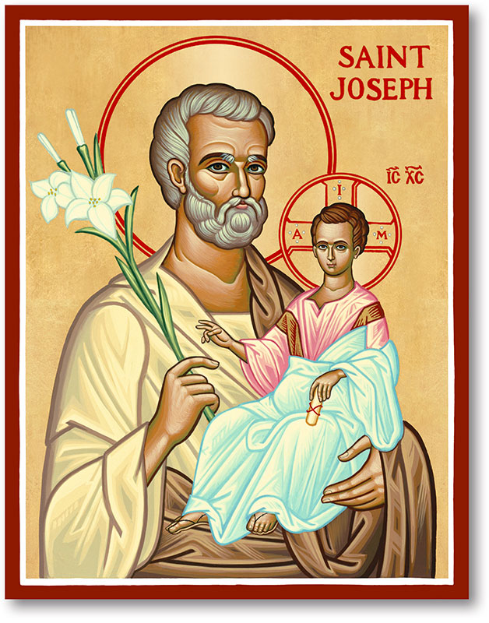
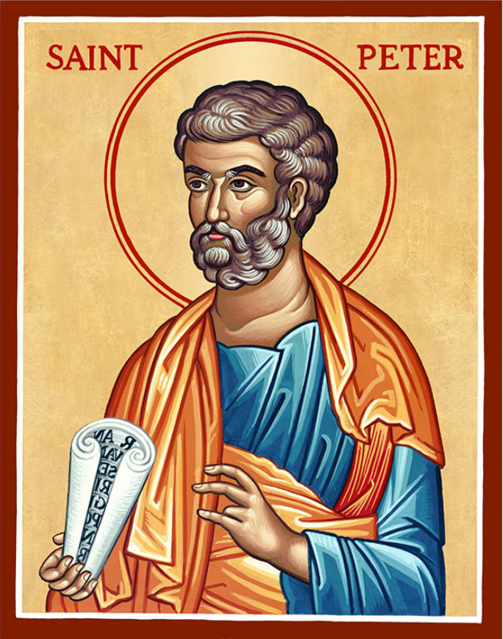
The Parish of Hannahstown
Saint Joseph’s and Saint Peter’s
Summer Schedule

Black Mountain Family of Parishes
Summer Notice Mass Times

HAHHAHSTOWN JULY MASS SCHEDULE:

There will be no weekday Masses Monday 13th July – Thursday 23nd July.

Weekday Mass will resume on Friday 24th July.

Weekend Masses will continue as normal during July.

HANNAHSTOWN JULY OFFICE CLOSURE

The parish office will be closed from Monday 13th July – Friday 17th July.

It will re-open on Monday 20th July.

ST. OLIVER PLUNKETT: No weekday Masses until 17th July

HOLY TRINITY: Mass times as normal throughout July

ST. AGNES: Mass times as normal throughout July

ST.MICHAEL’S: Mass times as normal throughout July

ST.TERESA’S: Mass times as normal throughout July

All weekend Masses will remain as normal throughout the summer in all Parishes in Blackmountain Family of Parishes

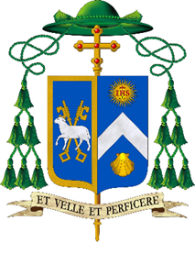
Statement by Bishop Alan McGuckian SJ in Response to Attack on Stephen Ogilvie and Recent Social Disorder
11th June 2026
My thoughts and prayers are firstly with Stephen Ogilvie, who sustained life-changing devastating injuries in a brutal and horrific attack on Monday evening. I also pray for his family and pay tribute to their appeal for calm as they support Stephen. The quick response of the local community and the statutory authorities coming to his assistance undoubtedly saved his life.
Over recent days, the streets of Northern Ireland and beyond have been marred by riotous behaviour and social disorder targeting family homes and businesses of migrants. People who have lived among us for years as good neighbours, friends and co-workers are now living in terror, for themselves and for their children. So many newcomers make an outstanding contribution to our communities, including our parishes. They are our friends. As a community we must stand in solidarity with them. Coordinated acts of senseless violence and destruction seek only to heighten tension across the community and must be condemned.
Shame on all those who have sought to mobilise, agitate, weaponise and politicise the fear and concerns of others over the last few days. All of us have a responsibility to de-escalate societal tension rather than stoke the flames of racism.
As a society, we also have a responsibility to address the real and tangible community concerns regarding safety and accountability, fears that demand honest, respectful attention. However, the destruction on our streets and the attacks on homes will not resolve any underlying issues, and violence will have to give way to dialogue and engagement. Into this space of meaningful conversation, politicians, community leaders and statutory agencies need to listen and act. In appealing for calm, I also call for support for the police and for community leaders.
As a society, we in Northern Ireland have journeyed too far on the road to reconciliation and paid too high a price in a legacy of suffering to risk retreating into conflict and racial oppression.
I ask that in all our parishes this weekend we pray for healing and peace and that the sacred dignity of each human person be upheld by all.

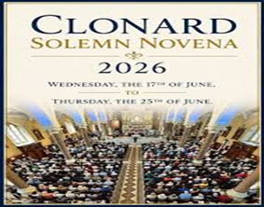
CLONARD NOVENA - Wednesday, June 17th and concludes on Thursday, June 25th, with the Feast Day of Our Mother of Perpetual on June 27th. The theme of the Novena this year, in line with the theme of the planned Synod of the Irish Church later this year, is “Called and Sent” Novena times in Church Porch.
The Novena will conclude with a Procession in honour of Our Mother of Perpetual Help on the evening of Thursday, June 25th, after the 8.00pm session.

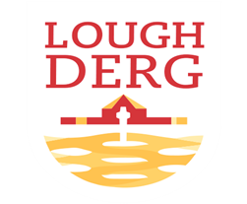

THREE DAY PILGRIMAGE TO LOUGH DERG: Bishop Alan McGuckian SJ and Jim Deeds will lead the Three-Day Pilgrimage to Lough Derg. Date: 19th – 21st June 2026. The bus will depart from St Patrick’s Church Donegal Street. Cost £100. Places are limited early booking advised. To book contact
Claire on 028 90690920 or email: pathwaystothefuture@downandconnor.org
BLACK MOUNTAIN FAMILY OF PARISHES NEWS
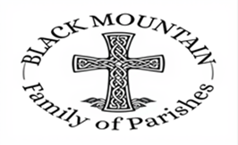
DIVINE INSPIRATION: You are invited to share their memories of St Michael's parish which is turning 50 this year. We hope to publish the best of them in our parish commemorative magazine. Also if anyone has any memories of the pilgrimage to the Holy Land - and photographs. Parishioners are also invited to say in 100 words or less what their faith means to them. We will endeavour to publish them! Please email or write to martinapurdy1@gmail.com or leave a hand written note with personal details for Martina's attention in the parish office.

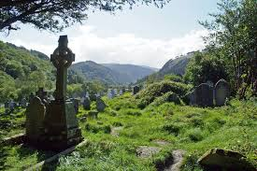
BLACK MOUNTAIN FAMILY OF PARISHES: Warmly invites you to a three-day pilgrimage to Glendalough from Monday 7th to Wednesday 9th September. Join us for a prayerful journey in the beautiful setting of St Kevin’s Glendalough, with opportunities for Mass, prayer, reflection, and fellowship. Tulfarris Hotel, prices include B&B, two 3-course evening meals, and transport: Single Room – £340, Double Room – £410, Twin Room – £410. All are welcome. Booking: Please contact your local parish office (cash payments only)
HANNAHSTOWN PARISH PASTORAL COUNCIL (PPC)

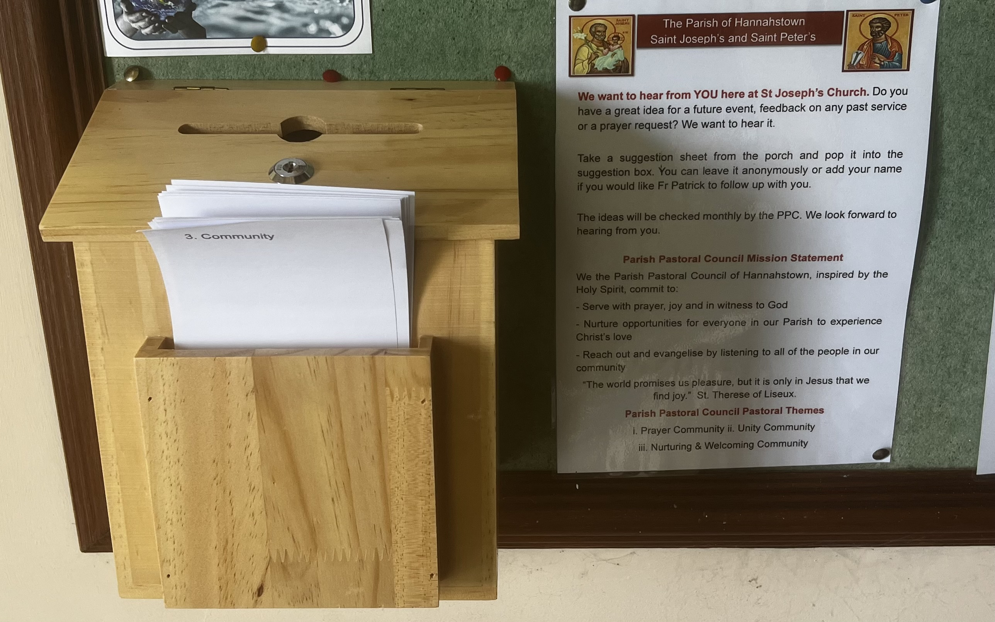
We want to hear from YOU here at St. Peter’s Church. Do you have a great idea for a future event, feedback on any past service or a prayer request? We want to hear it.

Take a suggestion sheet from the porch and pop it into the suggestion box. You can leave it anonymously or add your name if you would like Fr Patrick to follow up with you.

The ideas will be checked monthly by the PPC. We look forward to hearing from you.

Parish Pastoral Council Mission Statement
We the Parish Pastoral Council of Hannahstown, inspired by the Holy Spirit, commit to:
- Serve with prayer, joy and in witness to God
- Nurture opportunities for everyone in our Parish to experience Christ’s love
- Reach out and evangelise by listening to all of the people in our community
“The world promises us pleasure, but it is only in Jesus that we find joy.” St. Therese of Liseux.

Parish Pastoral Council Pastoral Themes
i. Prayer Community ii. Unity Community
iii. Nurturing & Welcoming Community

