
WEEKLY COLLECTIONS:
THE PARISH OF HANNAHSTOWN
17/5/26 Weekly Collection £645.12
17/5/26 Student Priest’s Collection £405.02
Collectors/ Volunteers Application Forms available on parish website, or in the Church Sacristy. Thank you.

HANNAHSTOWNTOWN COMMUNITY: SPRING/SUMMER FESTIVAL FRIDAY-12TH JUNE-SUNDAY JUNE 14TH Fri-Seniors Tea-Dance 12-3.30 pm -Live music/Bingo/Ballots Sat-Historical Society Coach Trip (more information to follow) Sun- Outdoor Mass at 11.30am-followed by Tea in the community Centre Please provide any Bric-a-Brac such as good clothing, toys, games, books, etc. by contacting Anto at Hannahstown Community Centre on 02890-309795 More info to follow

BAPTISMS DIOCESIAN AND PARISH NORMS:
Parents will be asked to complete a short form confirming whether any other person holds parental responsibility for the child and that they are aware of the request for baptism and have raised no objection. This procedure is required in line with diocesan guidance and civil law. Please bring with you a copy of the baby’s long birth certificate to the parish office.

CONSIDERING MARRIAGE?
“Above all, let your love for one another be intense.” (1 Peter 4:8)
We would be delighted to welcome couples to meet, view the church, and arrange their wedding. Please contact Parish Office
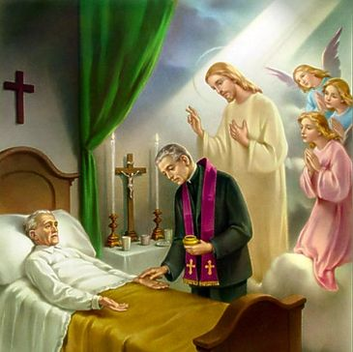
PASTORAL VISIT TO THE SICK AND HOUSEBOUND “The Lord is close to the broken-hearted.” (Psalm 34:18) Families are encouraged to let us know if a loved one is housebound and would need a visit from the priest. Contact Fr Patrick or the Parish office.

SAFEGUARDING IN OUR PARISH “Let the little ones come to me.” (Mark 10:14)
We are pleased to share that diocesan safeguarding requirements for 2026 have now been completed, helping ensure our parish remains a safe, respectful, and caring community.

ALL VOLUNTEERS: “Each of you has a gift to use in the service of others.” (1 Peter 4:10)
To support good safeguarding and governance, we invite all volunteers to complete a General Volunteer Application Form at the parish office. This helps us keep an up-to-date picture of parish life and ensures volunteers are properly supported

PARISH FINANCE MEETING: The Parish Finance Meeting will be held on Wednesday 27th May 2026 at 7.00pm in the Parish House. We encourage all members to attend as we continue to plan and support the ongoing work and mission of the parish. Thank you for your continued commitment and support.

CEMETERY COMMITTEE MEETING: The Cemetery Committee Meeting will be held on Thursday 28th May 2026 at 7.00pm in the Parish House. We encourage all committee members to attend as we continue to plan and support the ongoing care and maintenance of the parish cemetery. Thank you for your continued commitment and support.

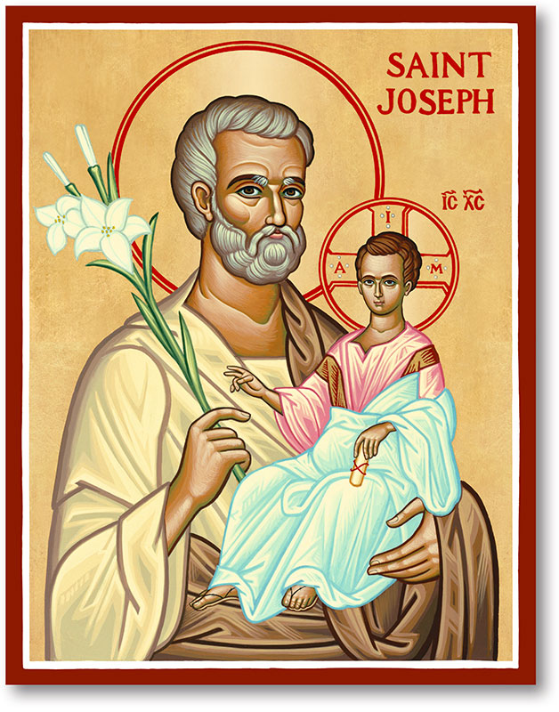
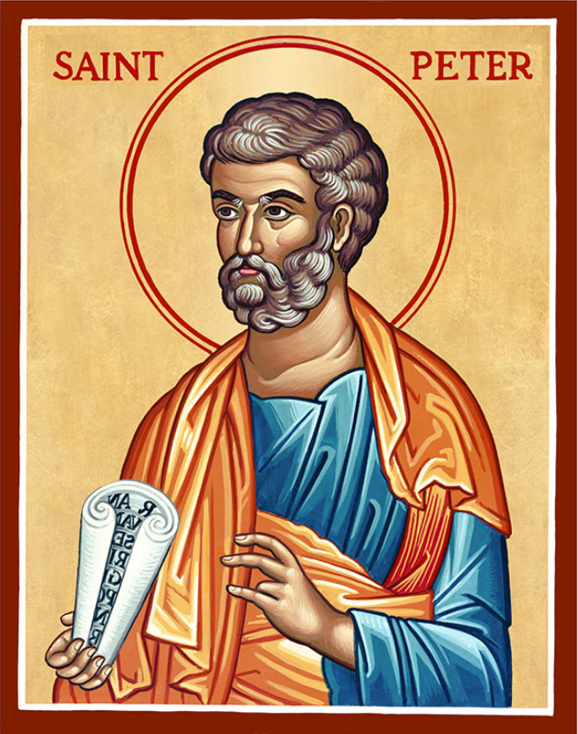
The Parish of Hannahstown
Saint Joseph’s and Saint Peter’s

24nd May 2026
Family of Parishes Emergency Sick Calls: 07549209775
Very Reverend Patrick Devlin, Parish Priest.
Chaplain to the Deaf Community Down & Connor. Chaplain Antrim Hospital Thurs / Frid (Emergency Calls)
Contact Fr. Patrick for Spiritual and Pastoral needs only, Tel: 07910 833699. Parish Secretary Grainne McArevey 02890 614567 Email address: hannahstown@downandconnor.org Website: parishofhannahstown.com

Monday | 9.15 am  6.30-7.30 pm | Morning Mass Prayer for Vocations  Adoration, Rosary and Divine Chaplet  https://churchmedia.tv/st-peters-church-2 | St Joseph’s  St Peter’s
Tuesday | 6.30-7.30 pm | Fr Patrick Away  Adoration, Rosary and Divine Chaplet | St Peter’s
Wednesday | 9.15 am  6.30-7.30 pm | Morning Mass Novena to Our Lady  Adoration, Rosary and Divine Chaplet | St Joseph’s  St Peter’s
Thursday | 9.15 am  6.30-7.30 pm | Morning Mass Novena to Our Lady  Adoration, Rosary and Divine Chaplet | St Peter’s  St Peter’s
Friday | 9.15 am  2.pm-8.30 pm  3.pm | Morning Mass Prayer to the Sacred Heart  Adoration, Rosary & Divine Mercy Chaplet  Adoration and Divine Mercy Chaplet | St Joseph’s  St Peter’s  St Joseph’s
Saturday | 6.00 pm  6.30-7.30 pm | Vigil Mass The Angelus Prayer  Adoration, Rosary and Divine Chaplet | St Joseph’s  St Peter’s
Sunday | 10.00 am  6.30-7.30 pm | Morning Mass Prayer to St Peter  Adoration, Rosary and Divine Chaplet | St Peter’s  St Peter’s
Sunday | 11.30 am  6.30-7.30 pm | Morning Mass Prayer to St Joseph  Adoration, Rosary and Divine Chaplet | St Joseph’s  St Peter’s
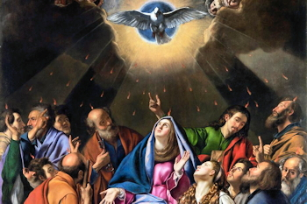
PENTECOST SUNDAY: Pentecost marks the fulfilment of Christ’s promise to send the Holy Spirit upon His Church. The Spirit descended upon the apostles, filling them with courage, wisdom, and faith to proclaim the Gospel to all nations. Pentecost is not simply an event of the past, but the living presence of God among us today. Through the Holy Spirit, the Church is renewed, strengthened, and guided in truth and love.


ANNIVERSARIES: – Peter Campbell, Rose Maguire, Jean Mulholland, Mary Hickland, Mary & Hugh Lavery, Rosie Maguire 1st Anniversary & Jean Mulholland, RIP.


CEMETERY SUNDAYS: – You are warmly invited to our Cemetery Sunday Masses, as we remember and pray for our loved ones.
Sunday 31st May – St Joseph’s Sunday,
7th June – St Peter’s, & Sunday 14th June – Tullyrusk.
Milltown Cemetery Sunday 10th May @ 3 pm. “I am the resurrection and the life, says the Lord; whoever believes in me will live, even though they die.”

HANNAHSTOWN PARISH PASTORAL COUNCIL (PPC)
Themes: Mercy, Healing and Unity May
HANNAHSTOWN PARISH MAY 2026 ST. JOSEPH’S CHURCH 200TH ANNIVERSARY

ACKNOWLEDGEMENT OF MARY PEYTON: The Parish Council invites parishioners to join in thanking Mary Peyton for over 60 years of devoted service to St Peter’s The Rock and St Joseph’s. This will take place tomorrow, Sunday 24th May 2026, at the 10.00am Mass in St Peter’s Church. During the Mass, Mary will receive a parish gift and the Knights of Columbanus (Council 151) “Honour of Faith” award. Refreshments will follow afterwards in Ballymacward School. Gift/Donation envelopes for Mary are available in the church porches and may be returned in the collection baskets. Thank you.

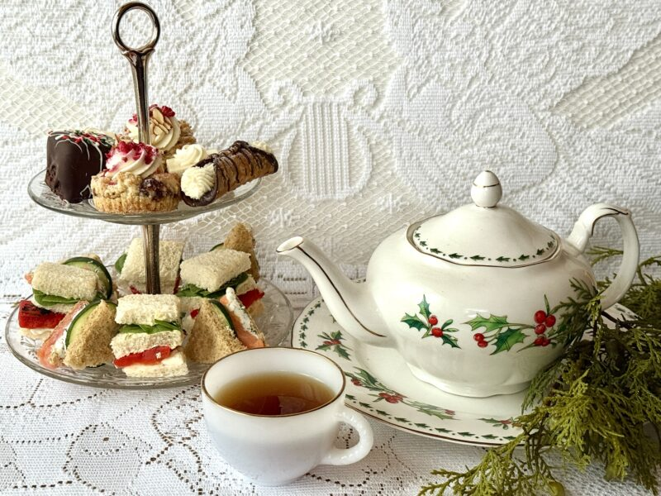
200th ANNIVERSARY: Tea Party for seniors: We warmly invite all seniors to join us for a special tea party celebrating our 200th year. Date: Wednesday 27th May in Hannahstown Community Hall. Everyone is very welcome! Please add your name to the sign-up sheet available in the church porches. If you require transport, kindly indicate this when signing up or contact us in advance. We look forward to celebrating together!

HANNAHSTOWN PARISH JUNE 2026 ST. JOSEPH’S CHURCH 200TH ANNIVERSARY
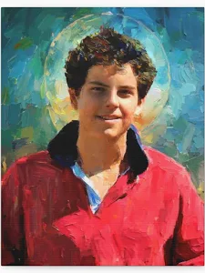
ST JOSEPH’S & ST PETER’S CHURCHS: The parish is delighted to celebrate the 200th anniversary of St Joseph’s Church with a special Corpus Christi celebration of faith, thanksgiving, and Eucharistic devotion. The celebration will also include a display on Blessed Carlo Acutis and his devotion to the Eucharist. All parishioners are warmly invited to join us for this special occasion. Time and date to be confirmed.

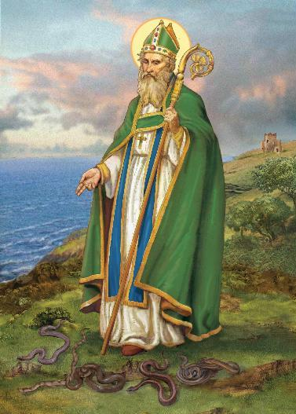
ST. PATRICK’S WAY: Walk in the footsteps of our Patron Saint on Saint Patrick’s Way Pilgrim. Walk in Downpatrick with guides Martina Purdy and Elaine Kelly on Sat 6 June and 8 August, and Mairead Sweeney on Sat 4 July, begin at Saint Patricks Centre with the fabulous 180° IMAX film of St Patrick, price includes entrance fees, internal bus transfers, pilgrimage lunch at the famous Saul Barn, plus a stamped Camino passport and a 6 mile pilgrimage walk finishing at Saint Patrick’s grave. Come and Be Amazed! (Duration 9am-approx 3pm, all for just £55) To book ring 02844 619000 or go to website www.saintpatrickcentre.com
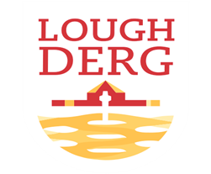

THREE DAY PILGRIMAGE TO LOUGH DERG: Bishop Alan McGuckian SJ and Jim Deeds will lead the Three-Day Pilgrimage to Lough Derg. Date: 19th – 21st June 2026. The bus will depart from St Patrick’s Church Donegal Street. Cost £100. Places are limited early booking advised. To book contact
Claire on 028 90690920 or email: pathwaystothefuture@downandconnor.org


ENCOUNTER WEEKEND DONEGAL: Radisson Blu Hotel, Letterkenny. 6.00pm - 10.30pm Friday 5th June. 9.00am - 10.30pm. Saturday 6th June. Expect to experience the presence of God through the celebration of the Sacraments, Spirit-led worship, inspiring talks, healing service, and fellowship. Come and be refreshed and empowered by the Holy Spirit and learn from the Saints how to live the lifestyle God intended you to live. Keynote Speakers: Patrick Reis: co-founder and Executive Director of Encounter Ministries USA & Fr. Patrick Gonyeau who serves with the U.S. Province of the Missionaries of the Precious Blood in Ohio. Bookings at https://encounterschoolofministrydoneg.regfox.com/encounter-conference-donegal
BLACK MOUNTAIN FAMILY OF PARISHES NEWS
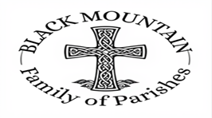
BLACK MOUNTAIN FAMILY OF PARISHES PRAYER BEFORE AN EXAM: Loving God be with me now, as I prepare for my exams. Thank you for the many talents and gifts you have given me and for the opportunity of education. Calm my nerves and anxiety. Help me to remember all that I have studied, to express it clearly and to answer the questions the very best I can. Holy Spirit, sit with me in my exam and always. AMEN
DIVINE INSPIRATION: You are invited to share their memories of St Michael's parish which is turning 50 this year. We hope to publish the best of them in our parish commemorative magazine. Also if anyone has any memories of the pilgrimage to the Holy Land - and photographs. Parishioners are also invited to say in 100 words or less what their faith means to them. We will endeavour to publish them! Please email or write to martinapurdy1@gmail.com or leave a hand written note with personal details for Martina's attention in the parish office.
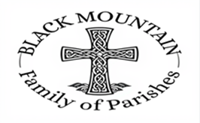
FIRST DEVOTIONS: will take place in St. Matthias’s Church, Glen Road on 6th June
3.00 p.m. Adoration of the Blessed Sacrament, Confessions and Act of Consecration, Rosary and Divine Mercy Chaplet. 4.00 p.m. Holy Sacrifice of the Mass

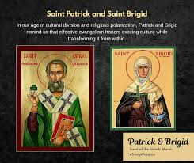
BLACK MOUNTAIN FAMILY OF PARISHES: invites you to a three-day pilgrimage to the Shrines of St Brigid and St Oliver Plunkett on 10th, 11th and 13th June. Ballymascanlon Hotel, single Room £380 Double Room £450 Twin £530 B&B and 2 evening meals 3 course transport included.
A time of Mass, prayer and fellowship as we journey together in faith and step away from the busyness of life.
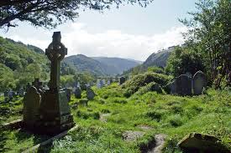
All are most welcome. Booking: Contact your local parish office (cash only).
BLACK MOUNTAIN FAMILY OF PARISHES: Warmly invites you to a three-day pilgrimage to Glendalough from Monday 7th to Wednesday 9th September. Join us for a prayerful journey in the beautiful setting of St Kevin’s Glendalough, with opportunities for Mass, prayer, reflection, and fellowship. Tulfarris Hotel, prices include B&B, two 3-course evening meals, and transport: Single Room – £340, Double Room – £410, Twin Room – £410. All are welcome. Booking: Please contact your local parish office (cash payments only)
KINGHTS OF COLUMBANUS 151 FAMILY OF PARISHES NEWS

ALL-IRELAND RALLY: takes place in Belfast on Saturday 4th July. Please join us to make a stand to protect Ireland's unborn babies. Coaches will be travelling from towns across Northern Ireland. To book your seat contact 02890278484/ 07592280522 or email info@preciouslife.com

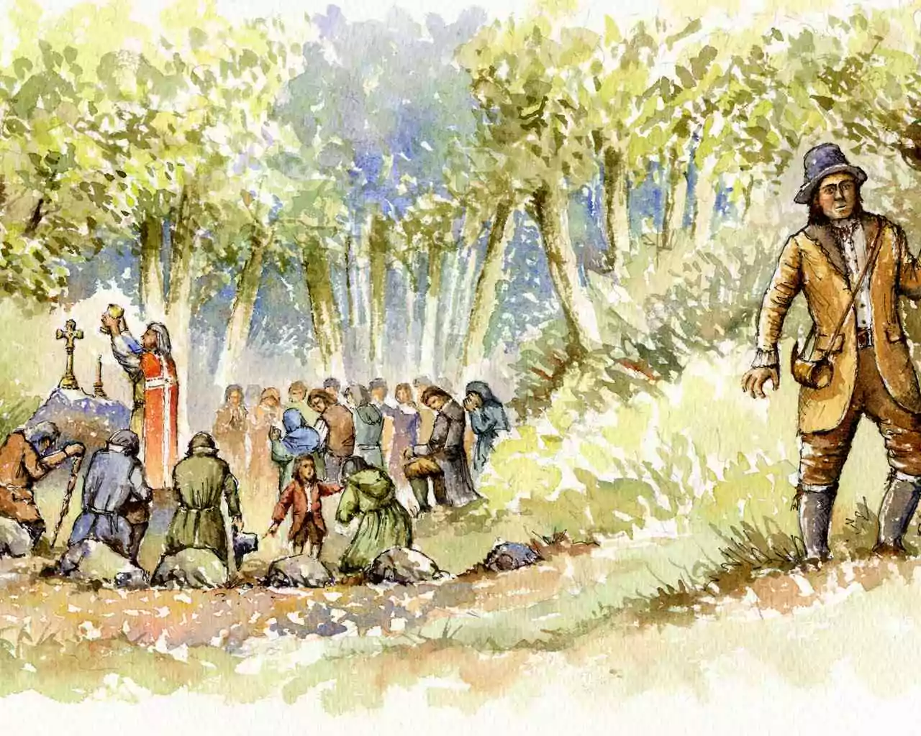
HOLY MASS CELRBRATED: The Mass Rock in Colin Glen is one of several authentic historical Mass Rocks (secret open-air altars used during the Penal Laws) located in the hills and glens surrounding Hannahstown: Colin Glen Mass Rock: A secluded site at the base of a ravine, marked by a wooden cross and a stone altar with inscribed crosses. It is accessible via a trail from the Colin Glen Visitor Centre. Mass at the Mass Rock – Colin Glen. The parish warmly invites you to a special celebration of Holy Mass at the historic Mass Rock in Colin Glen on Saturday 20th June, at 11.30am rosary walk time 10am Eucharistic Adoration. This sacred site, is one of several places where Mass was celebrated in secret during the time of the Penal Laws. In those difficult days, the faithful gathered quietly in the hills keeping alive the gift of the Eucharist. As we gather once again in this holy place, we honour their courage and deepen our own faith. Come and join us for this meaningful and prayerful celebration, reconnecting with the faith of our forebears. All are most welcome.

