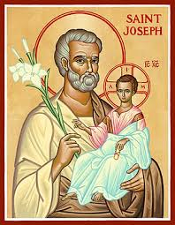

**The Parish of Hannahstown**

I, the undersigned, hereby acknowledge that the Parish Priest/Administrator of the above Parish, has provided me with full details of the roles, responsibilities and safeguarding in regards to the role of a Welcomer

I am also aware that the following Code of Conduct and Confidentiality applies to all

who accept this voluntary role.

* While serving and thereafter, volunteers shall keep confidential all matters of record or reference, whether or not communicated or discussed in their work or among those serving.
* Members shall always speak and act, inside and outside of the Parish in a manner supportive to the Parish.
* Members shall avoid any conflict of interest, or the appearance of a conflict of interest with the Parish.

I hereby agree to accept the Parish Priest’s/Administrator’s offer to serve as a volunteer

of the Parish.

________________________________

_______________________

**Member**

**Date**

**_________________________________________**

**PP/Admin**

**______________________________**

**Date**