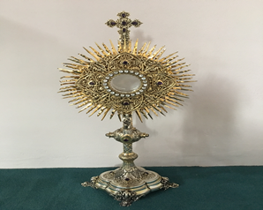
EUCHARISTIC ADORATIONSt Peter’s Church - Every Friday from 2 pm – 8.30 pm. Every evening Adoration & Prayer in St Peter’s Church 6.30 pm – 7.30 pm
THE PARISH OF HANNAHSTOWN
https://churchmedia.tv/st-josephs-church https://churchmedia.tv/st-peters-church-2

ANNIVERSARIES – Susan Armstrong, Rose Douglas, Tony Edwards, John & Margaret Keegan, Daniel Magill, John Magill, Mary Martin McLaughlin, Eileen O’Hara & Frankie O’Hara RIP.
Margaret Dunlop 1st Anniversary RIP
MONTHS MIND - Elizabeth Donnelly RIP

WEEKLY COLLECTIONS
02/02/25 Weekly Collection £808.07
02/02/25 Monthly Collection £815.57
Thank you to everyone for their generosity to the Parish.

BAPTISMS
Recently Baptised were babies Luna Myra Donaghy Gray, Ría Níamh Hannaway
& Roísa Marie Willoughby. We welcome them all into our Parish Community.
To book Baptisms please present the long birth certificate into the parish office.
HANNAHSTOWN COMMUNITY HALL

Please contact: Anthony Adams for any enquiries on 90 309795.
Mon – Fri 10 am – 1 pm. Monday – Coffee Morning after 9.15 am Mass. Wednesday Morning Women Group after 9.15 am Mass

Important Date and Congratulation…..Sunday 23rd Feb 2025 Celebrating 20 years of Service for the Hannahstown Community Association in Hannahstown and beyond…..Programme to follow
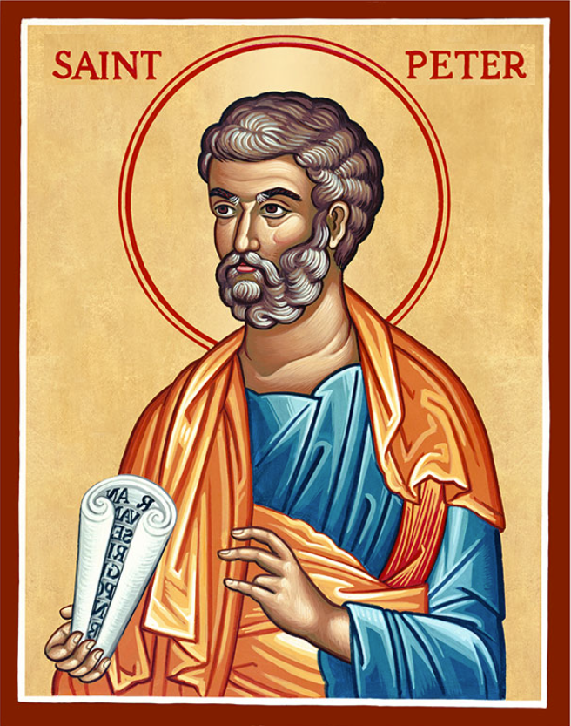
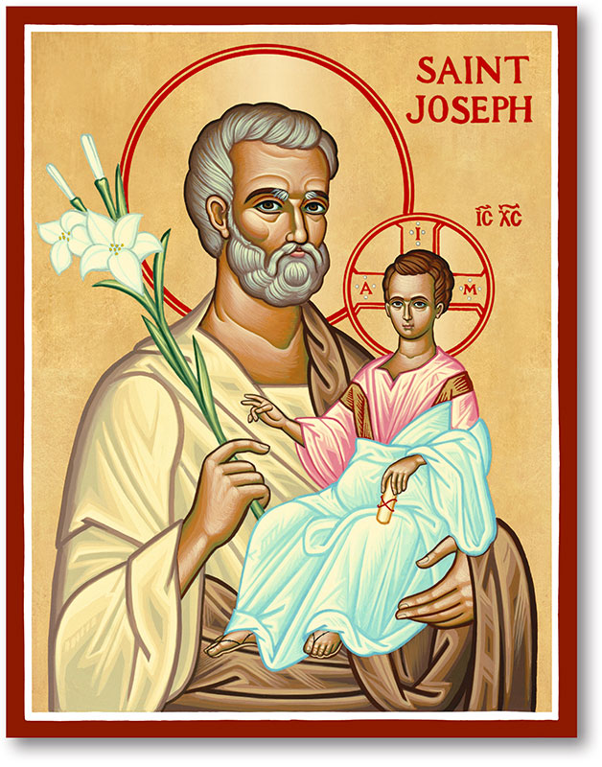
The Parish of Hannahstown
Saint Joseph’s and Saint Peter’s

16th February 2025
Fifth Sunday in Ordinary Time

Family of Parishes Emergency Sick Calls: 07549209775
Monday 09.15 am (Prayer for Vocations) Saint Joseph’s
Tuesday Fr. Patrick’s day off.
Wednesday 9.15 am (Parish novena to Our Lady) St Joseph’s
Thursday 9.15 am (Parish novena to Our Lady) St Peter’s
Friday 9.15 am (Sacred Heart Prayer) Saint Joseph’s
Saturday 6:00 pm (St Michael the Archangel Prayer) Saint Joseph’s
Sunday 10:00 am (Prayer for Pope’s intentions) Saint Peter’s
Sunday 11:30 am (Saint Joseph Prayer) ( BSL Signed ) Saint Joseph’s

Very Reverend Patrick Devlin Parish Priest,
Chaplain to the Deaf Community, Down and Connor Diocese
Chaplain to Antrim Area Hospital Thursday & Friday (Emergency calls)
Fr. Patrick, for Spiritual and Pastoral needs only, thank you Tel: 07910 833699
Parish Secretary: Mrs Grainne McArevey Tel: 028 90614567
Parish Email: hannahstown@downandconnor.org Parish Website: https://www.parishofhannahstown.com

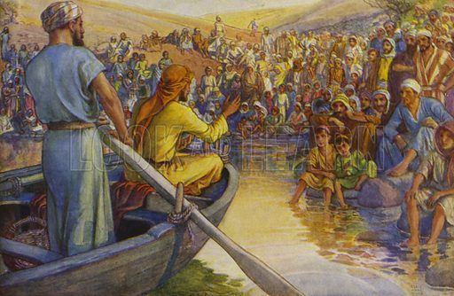

Today’s Gospel tells how Jesus surprised Simon by climbing in his boat and going out a little way from the shore to teach the people. Then Jesus made another surprising move by asking Simon to put out into the deep and lower his nets for a catch. Simon (to whom Jesus would later give the name Peter) seems at first to offer an objection; but inspired by the presence of Jesus, and illuminated by His word, Simon does as he is asked. It is the response of faith, the response that we too are called to give; and the attitude of openness that the Lord asks of all His disciples, especially insofar as they have duties of responsibility in the Church. It is Simon’s trusting obedience that prompts the miraculous catch of fish. When we come with generosity to His service, Jesus accomplishes great things in us.

HANNAHSTOWN PARISH / FAMILY OF PARISHES / PATHWAYS
Recharge is a young adult group based in Down and Connor for those aged 18 to 35. The group meet twice monthly on the first and third Tuesday of each month to “recharge” the spiritual batteries through Adoration, intellectual formation and social gatherings.

We will be meeting on Tuesday the 4th and 18th of February at 7.30pm in St Colmcille’s Church, Ballyhackamore. All welcome!

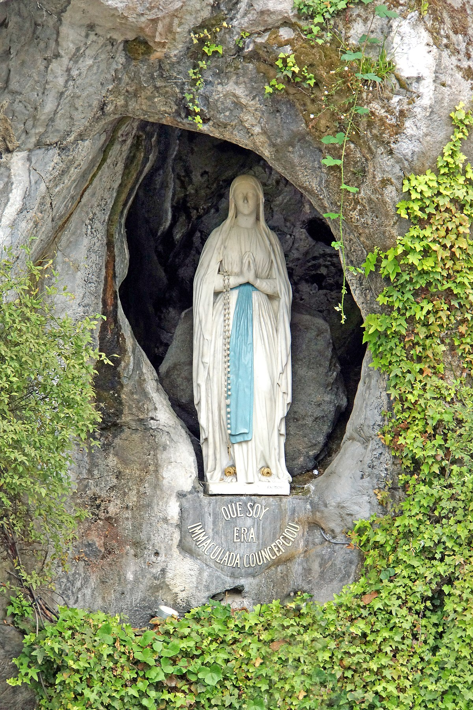
DOWN & CONNOR PILGRIMAGE TO LOURDES - Down & Connor Pilgrimage to Lourdes 2025: Celebrating the Jubilee Year and our 40th Annual Diocesan Pilgrimage: 9/10 – 15th/16th July. 5 & 7 Night options available. Please Visit www.downandconnor.org/lourdes for more information or call the Pilgrimage Office on (028) 9077 0162 or email lourdes@downandconnor.org Youth Team (9-16th July): applications are now open (see website for details)


The Parish is requesting prices for grounds work, including work at Saint Joseph's and Saint Peter's Cemeteries. This would include grass-cutting (14 cuts per calendar year), care of shrubs, weed spraying, and removal. please contact the parish office before Friday 14th 2025.

Message from Fr. Patrick Devlin

HANNAHSTOWN PARISH / FAMILY OF PARISHES / PATHWAYS

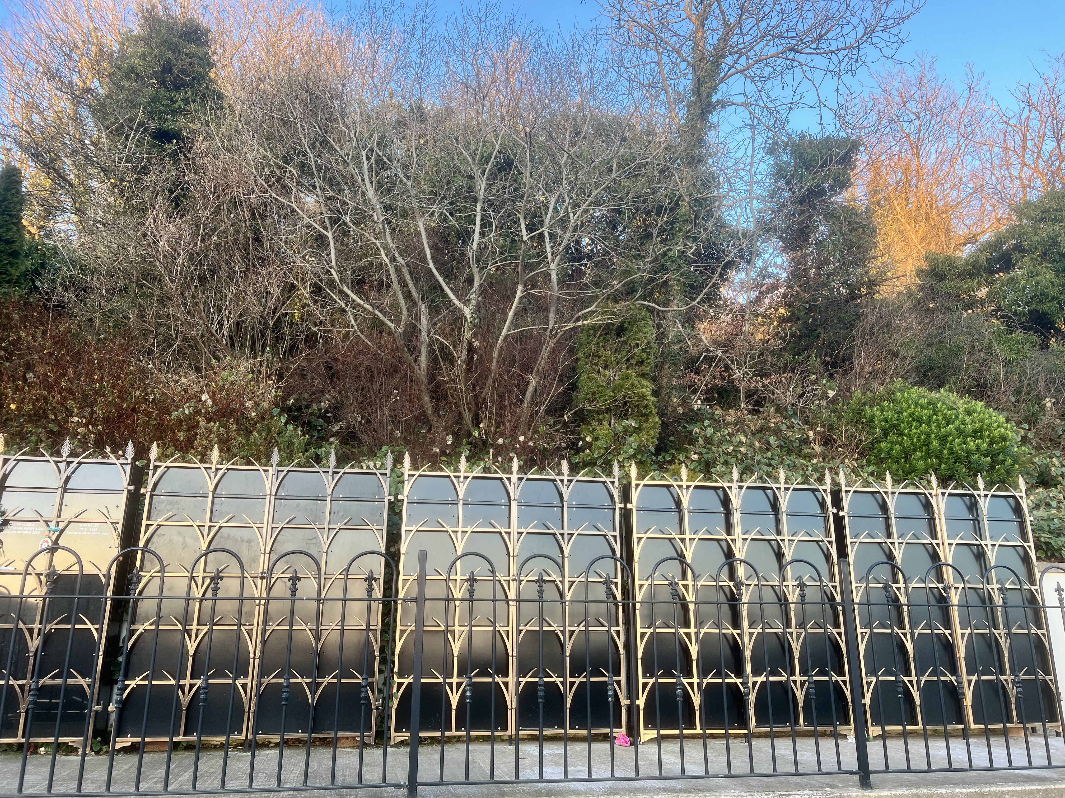
In Hannahstown Parish, after much advice and consideration, I am pleased to announce the sale of leases for vaults in our Parish Columbarium

This process will begin on Thursday the 13th of February 2025.
Please contact the parish office
(by phone only) from the above date, Mon – Fri during the hours of 9 am – 11 am.

We will require your name, address, contact number and email to begin this process.

The cost is £2000 for a (2-person remains) Urn Vault & £3,500 for a (4-person remains Urn Vault).

Priority will be given to those families who have Ashes of loved ones ready to be interred.

I want to advise you spiritually and pastorally that if you do have a loved one's Ashes at home, please consider a dignified interment in our beautiful Parish Columbarium.

I refer you to (page 10) of Bishop Alan’s “A Family Guide to Planning and Celebrating a Funeral in the Catholic Church”.

https://www.downandconnor.org/wp-content/uploads/2024/11/A-Family-Guide-to-Planning-and-Celebrating-a-Funeral-in-the-Catholic-Church.pdf.

May our loved ones Rest in Peace.

HANNAHSTOWN PARISH
St Joseph’s Church Cemetery (Mass) Sunday 25th May @ 3 pm
Tullyrusk Cemetery (Mass) Sunday 15th June @ 1.30 pm
St Peter’s Church, The Rock Cemetery (Mass) Sunday 8th June @ 1.30 pm

CEMETERY SUNDAY IN BELFAST CEMETERIES
Milltown (Service) Sunday 11th May @ 3 pm
City (Service) Sunday 18th May @ 3 pm

