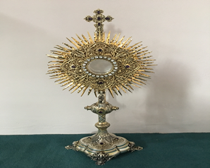
EUCHARISTIC ADORATION in St Peter’s Church - Every Friday from 2 pm – 8.30 pm.
THE PARISH OF HANNAHSTOWN
Every evening with in St Peter’s Church Adoration & Prayer from 6.30 pm – 7.30 pm
https://churchmedia.tv/st-josephs-church https://churchmedia.tv/st-peters-church-2

MONTH’S MIND – Ciaran Devlin & Ann Milligan RIP
ANNIVERSARIES – Bertie & Kathleen Buchanan,
Rosie Crilly (1st A), Pat & Nora McGreevy,
Isobel McLarnon & Maura & Kelly O’Reilly RIP


WEEKLY COLLECTIONS
1/6/25 Weekly Collection £1,036.91
1/6/25 Monthly Collection £ 712.85


Thank you to everyone for their generosity to the Parish.
BAPTISMS
To arrange Baptisms please present the long birth certificate to the parish office. Baptisms will be arranged upon request.

CEMETERY SUNDAY
CEMETERY SUNDAY for Tullyrusk is
Sunday 15th June @ 3 pm. Holy Mass will be celebrated.

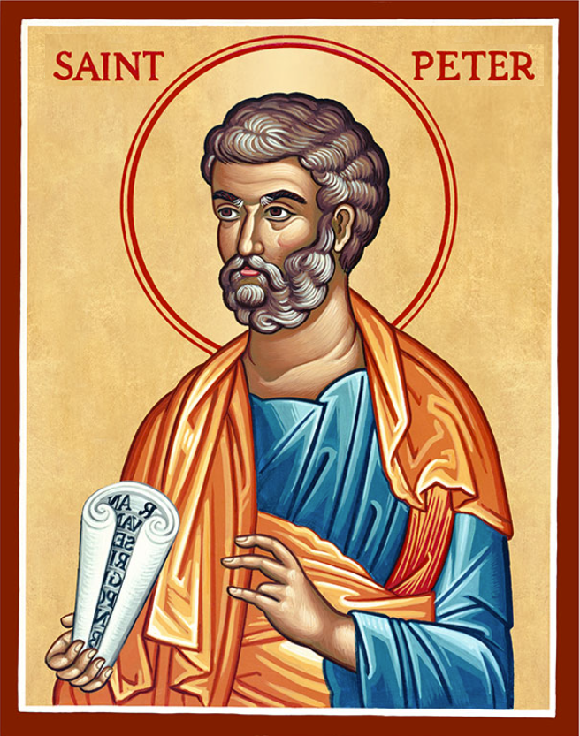
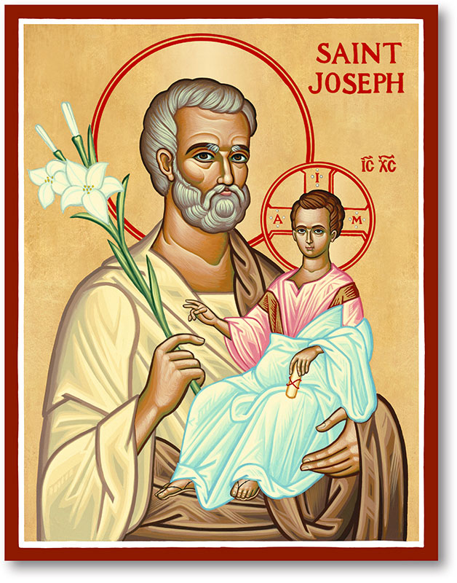
The Parish of Hannahstown
Saint Joseph’s and Saint Peter’s

8th June 2025
PENTECOST SUNDAY

Family of Parishes Emergency Sick Calls: 07549209775
Monday 09.15 am (Prayer for Vocations) St Joseph’s
Tuesday Fr. Patrick’s day off.
Wednesday 9.15 am (Parish novena to Our Lady) St Joseph’s
Thursday 9.15 am St Peter’s
Saturday 6:00 pm (St Michael the Archangel Prayer) St Joseph’s
Sunday 10:00 am (Prayer for Pope’s intentions) St Peter’s
Sunday 11:30 am (Saint Joseph Prayer) ( BSL Signed ) St Joseph’s
Very Reverend Patrick Devlin, Parish Priest,
Chaplain to the Deaf Community, Down and Connor Diocese
Chaplain to Antrim Area Hospital, Thursday & Friday (Emergency calls)
Fr. Patrick, for Spiritual and Pastoral needs only, thank you Tel: 07910 833699
Parish Secretary: Mrs Grainne McArevey Tel: 028 90614567
Parish Email: hannahstown@downandconnor.org Parish Website: https://www.parishofhannahstown.com

PENTECOST SUNDAY

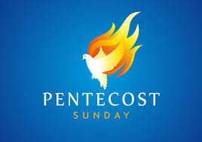
The Feast of Pentecost reminds us that there is an important connection between the gifts of peace and forgiveness and the action of the Holy Spirit.
Let us be reminded that our Irish Bishops have encouraged us to pray for peace in the Holy land, for Ukraine, Sudan and especially for the catastrophe in Gaza. We in Ireland must pray for a change of heart. Throughout the month of June the month of the Sacred Heart of Jesus – we call on everyone to pray for an outpouring of the compassion of God on a heartless world. “we echo Pope Leo XIV’s recent appeal to allow into Gaza ‘the entry of dignified humanitarian aid and to put an end to the hostilities, whose heart-breaking price is paid by the children, elderly and the sick.’”.
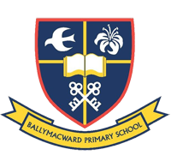
No matter what suffering there is in the world and in our lives there is also beauty. Our Parish School Ballymacward Primary School,
HANNAHSTOWN PARISH SCHOOL / COMMUNITY PLAYGROUP
22 Rock Road, Stoneyford, Lisburn, Co Antrim, BT28 3SUTel: (028) 92648130, Principal: Mr Hugh Kennedy
Email: info@ballmacwardps.lisburn.ni.sch.uk
Ballymacward Community Pre-School Playgroup - Supervisor: Ms Sarah Scott. Tel: (028) 9264 8515
HANNAHSTOWN PARISH/FAMILY OF PARISHES

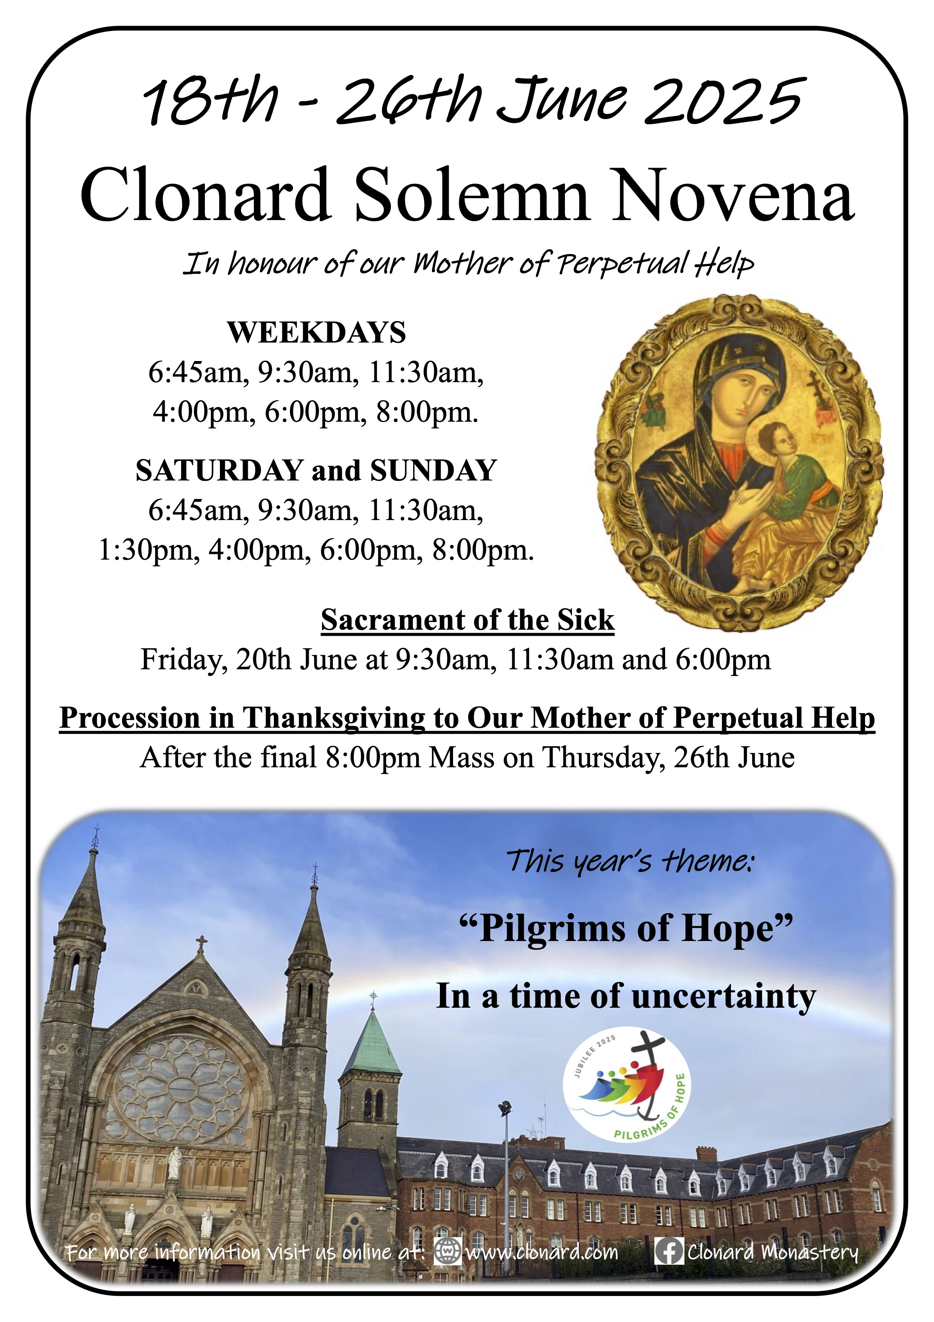

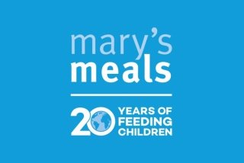
. Our Parish annual collection will be taken up by Mary’s Meals after the Masses on 21st and 22nd June.
HANNAHSTOWN PARISH/FAMILY OF PARISHES

COUNCIL FOR MIGRANTS, REFUGEES AND JUSTICE AND PEACE – The Irish Bishop’s Conference has requested that an annual collection be taken up for this charity to be used to support the work of the Council to provide pastoral outreach to marginalised and vulnerable communities. Please see letter from Bishop Alan on Church noticeboards. The collection will be taken up in our parish on the weekend of 28th & 29th June. Thank you in anticipation.
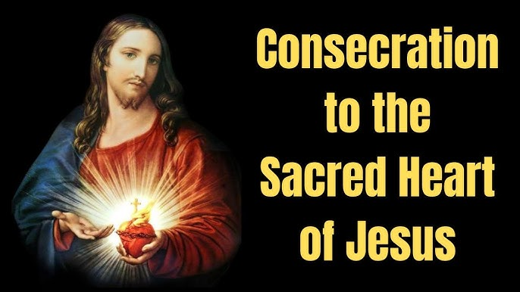
Consecration of Ireland to the Sacred Heart – Sunday 22 June 2025 - On Corpus Christi Sunday, 22nd June, Archbishop Eamon Martin will consecrate Ireland to the Sacred Heart. Bus to Knock from Belfast also picking up in Sprucefield and Banbridge. £30, children free. For further information and
to book please contact Orla 07545452362

All-Ireland Rally for Life takes place in Dublin on Saturday 5th July. Make a stand to protect Ireland's unborn babies. Coaches will be travelling from towns across Northern Ireland. To book your seat contact 02890278484/ 07592280522 or email info@preciouslife.com
The Sacred Heart Crusade commenced with the papal blessing of four pilgrim Sacred Heart Statues on the 8th January 2025 in Rome. The Statue will arrive in St Oliver Plunkett parish on the afternoon of Sunday 15th June. On Sunday evening at 7pm there will be adoration of the Sacred Heart in the Church.
On Monday 16th June, we will dedicate our Mass to the Sacred Heart
with children from the primary school and music at 10am.
Everyone is welcome.

