
THE PARISH OF HANNAHSTOWN
WEEKLY COLLECTIONS:
7/4/26 Weekly Collection £1,158.40, 7/4/26 Easter Collection £ 760.49
7/4/26 Catholics in the Holy Land £396.53 Collectors/ Volunteers Application Form available on parish website, thank you to everyone.


BAPTISMS DIOCESIAN AND PARISH NORMS:
Parents will be asked to complete a short form confirming whether any other person holds parental responsibility for the child and that they are aware of the request for baptism and have raised no objection. This procedure is required in line with diocesan guidance and civil law. Please bring with you a copy of the baby’s long birth certificate to the parish office.

CONSIDERING MARRIAGE?
“Above all, let your love for one another be intense.” (1 Peter 4:8)
We would be delighted to welcome couples to meet, view the church, and arrange their wedding. Please contact Parish Office
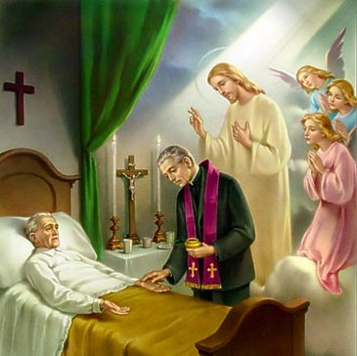
PASTORAL VISIT TO THE SICK AND HOUSEBOUND “The Lord is close to the broken-hearted.” (Psalm 34:18) Families are encouraged to let us know if a loved one is housebound and would need a visit from the priest. Contact Fr Patrick or the Parish office.


SAFEGUARDING IN OUR PARISH “Let the little ones come to me.” (Mark 10:14)
We are pleased to share that diocesan safeguarding requirements for 2026 have now been completed, helping ensure our parish remains a safe, respectful, and caring community.


ALL VOLUNTEERS: “Each of you has a gift to use in the service of others.” (1 Peter 4:10)
To support good safeguarding and governance, we invite all volunteers to complete a General Volunteer Application Form at the parish office. This helps us keep an up-to-date picture of parish life and ensures volunteers are properly supported.

GRASS CUTTING AND GROUNDS MAINTENANCE - Quotations are requested for the cemetery grass cutting and grounds maintenance at Hannahstown and the Rock. Details, including specifications, are available from the Parish Office on 028 90614567. The successful bidder must have the specified liability insurance in place; i.e., Tenderers must provide evidence of Employers and Public Liability Insurance to the levels of £1,000,000.00 and £5,000,000.00, respectively.
Quotations are to be returned by 11:00 am on Wednesday, 15th April 2026.

HANNAHSTOWNTOWN COMMUNITY SPRING/SUMMER FESTIVAL FRIDAY-12TH JUNE-SUNDAY JUNE 14TH Fri-Seniors Tea-Dance 12-3.30 pm -Live music/Bingo/Ballots Sat-Historical Society Coach Trip (more information to follow) Sun- Outdoor Mass at 11.30am-followed by Tea in the community Centre Please provide any Bric-a-Brac such as good clothing, toys, games, books, etc. by contacting Anto at Hannahstown Community Centre on 02890-309795 More info to follow on Events
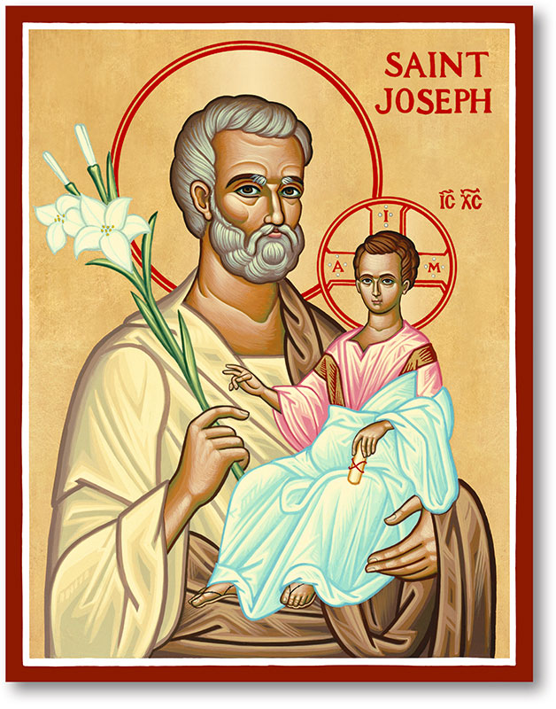
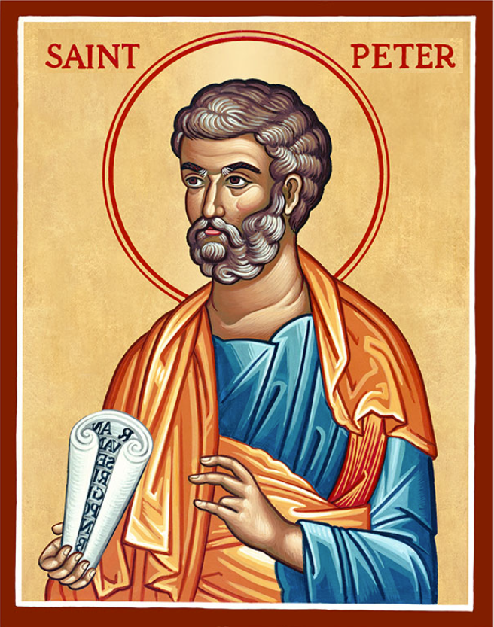
The Parish of Hannahstown
Saint Joseph’s and Saint Peter’s

12th April 2026
DIVINE MERCY SUNDAY

Family of Parishes Emergency Sick Calls: 07549209775
Very Reverend Patrick Devlin, Parish Priest.
Chaplain to the Deaf Community Down & Connor. Chaplain Antrim Hospital Thurs / Frid (Emergency Calls)
Contact Fr. Patrick for Spiritual and Pastoral needs only, Tel: 07910 833699. Parish Secretary Grainne McArevey 02890 614567 Email address: hannahstown@downandconnor.org Website: parishofhannahstown.com

Monday | 9.15 am | Prayer for Vocations & Requiem Mass for Phillis Vincent RIP.  Coffee morning. Hannahstown Community Hall afterwards. | St Joseph’s
Tuesday | 11.30 am | Requiem Mass for Dennis Quinn RIP | St Joseph’s
Wednesday | 9.15 am  10.00 am | Morning Mass  Requiem Mass Edgar Saycon RIP Holy Cross Church | St Joseph’s
Thursday | 9.15 am | Morning Mass | St Peter’s
Friday | 9.15 am | Morning Mass | St Joseph’s
Saturday | 6.00 pm | Vigil Mass | St Joseph’s
Sunday | 10.00 am | Morning Mass | St Peter’s
Sunday | 11.30 am | Morning Mass | St Joseph’s

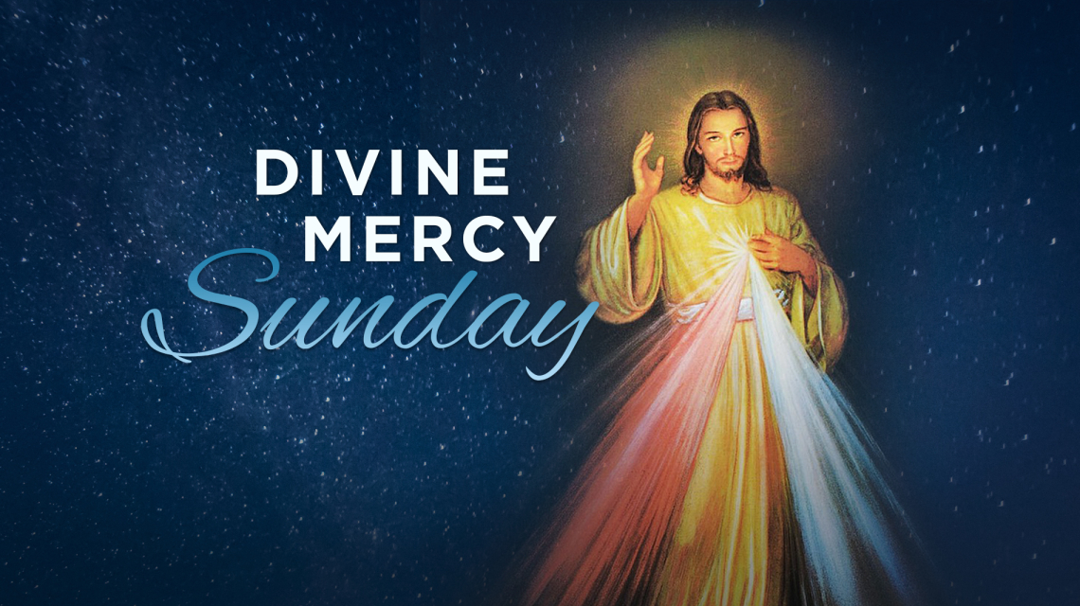
We will be celebrated on the Second Sunday of Easter, on the 12th April 2026 in Hannahstown Parish in St Joseph’s Church. The Feast was promoted through the revelations associated with Saint Faustina Kowalska and was established for the universal Church by Pope John Paul II in 2000.
Emphasis on the Divine Mercy Image and Devotion, Confession and Trust in God’s Mercy. The Divine Mercy Chaplet 2-3 Adoration, Confessions and Rosary. Blessing of Divine Image before 3:00 pm Holy Mass Gospel of John 20:19–31 In Gospel of John 20:19–31, the risen Christ appears to His fearful disciples, bringing peace where there was doubt. Thomas struggles to believe without seeing, voicing the honest scepticism of many hearts. Jesus meets him with mercy, inviting him to touch and believe rather than condemning his doubt. The passage ends by blessing those who believe without seeing, pointing to faith grounded in trust, not just proof.

REST IN PEACE: Phyllis Vincent & Dennis Quinn RIP

ANNIVERSARIES – Kathleen Brankin, Michael Campbell, Nora McCarthy

& Ryan Stranney RIP

Team HCB Zambia 2026: A Legacy of Giving - Thank you to everyone who supported the collection for Zambia 2026. Almost £2,500 was raised over the weekend, and Holy Cross Zambia Team are more than grateful to the parish of Hannahstown for their generosity & Kindness. The team will report back after the trip. Thank you so much.

HANNAHSTOWN PARISH PASTORAL COUNCIL (PPC)
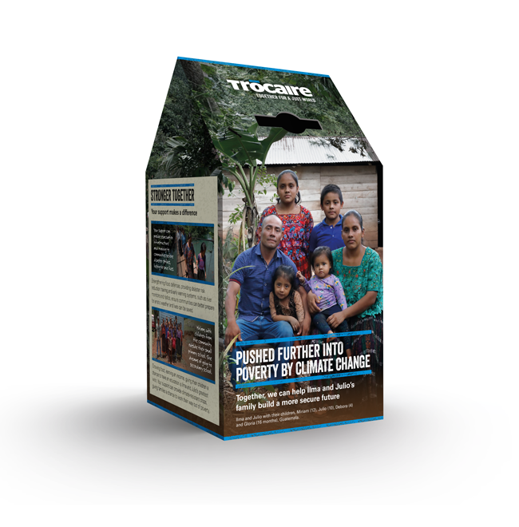
Themes: Mercy, Healing and Unity
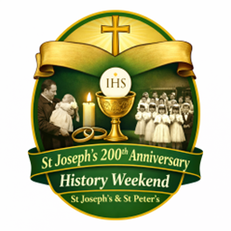
PLEASE COLLECT YOU TROCIARE BOXES AND LEAVE TO OFFICE OR IN THE SACRISTY, THANK YOU.

HISTORY WEEKEND: As we prepare to celebrate 200 years of St Joseph’s Church, we are organising a special History Weekend to honour the story of both St Joseph’s and St Peter’s. We warmly invite parishioners to share any photographs of parish life — Baptisms, First Confession, First Holy Communion, Confirmation, Weddings, visiting Priests or Bishops, School events, Parish Missions, or old photographs of the Churches. Please place photos in an envelope with: Your name, Contact number, Brief details of the photo. Photos can be left in the Sacristy or Parish Office by Monday 12th April and will be carefully returned after the event. Help us celebrate the generations of faith that have shaped our parish.

HANNAHSTOWN PARISH APRIL 2026 ST. JOSEPH’S CHURCH 200TH ANNIVERSARY

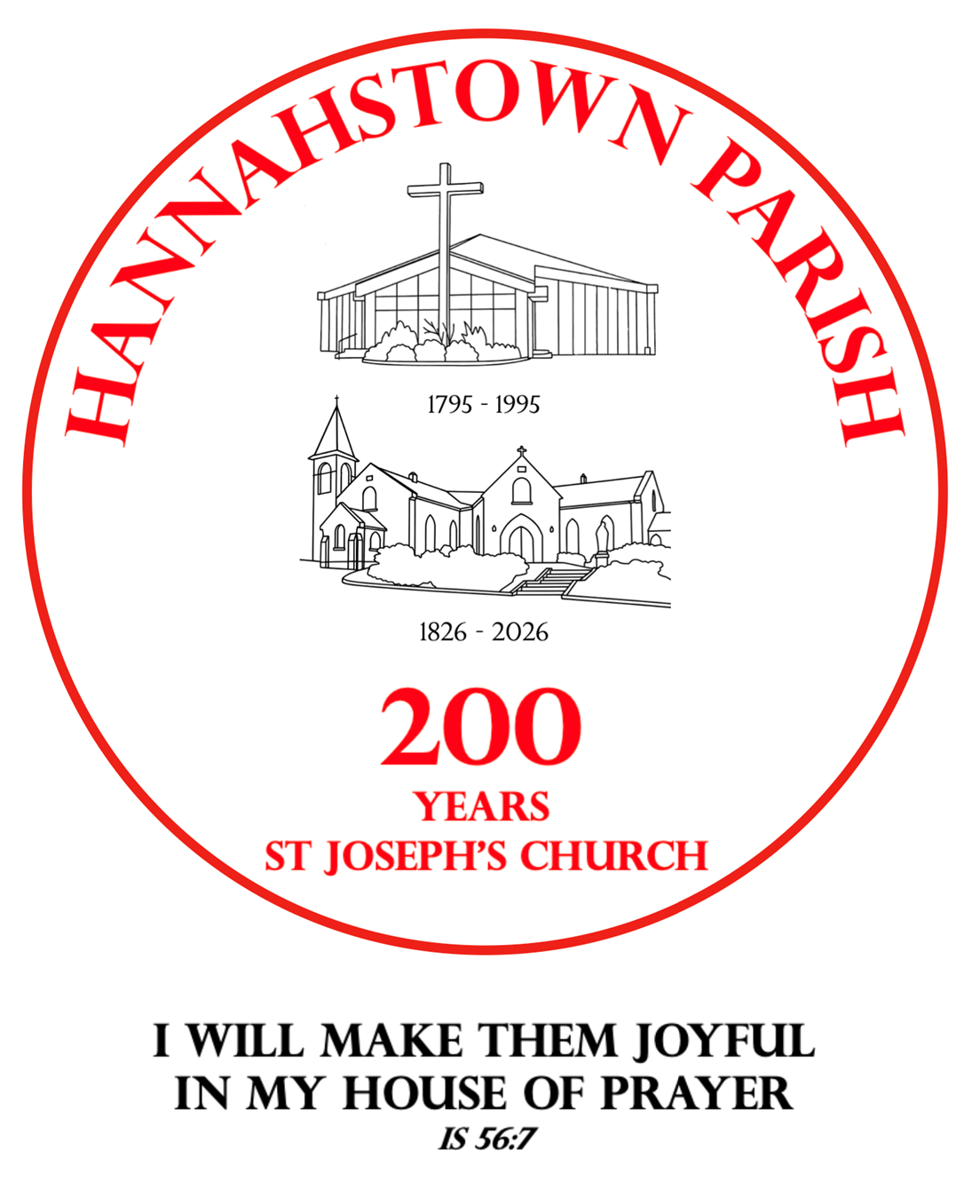
CONTINUING THE AMAZING JOURNEY: …April is a time of new life, resurrection, and renewed hope in our parish and in our faith. In that spirit, we warmly invite families to gather in celebration and thanksgiving for the gift of Baptism.
All children baptised in the past three years, along with their families, are invited to a special Blessing and Celebration Service:

A joyful and prayerful celebration including a short Liturgy of the Word, Procession, and Blessing of Children and Families, with Guardian Angel prayer cards given as a gift.
Afterwards, join us outside for ice cream, balloons, and fun characters for the children.
A lovely opportunity to give thanks and continue the journey of faith together. Pray for nice WEATHER! All are welcome.


TREE PLANTING AND TIME CAPSULE CELEBRATION:

As part of our 200-year celebrations of St Joseph’s Church, we invite parishioners to a special moment of remembrance and hope for the future.

A tree will be planted as a symbol of faith and growth, and a time capsule will be created to capture memories of our parish for future generations. Further details to follow.

HANNAHSTOWN PARISH MAY 2026 ST. JOSEPH’S CHURCH 200TH ANNIVERSARY
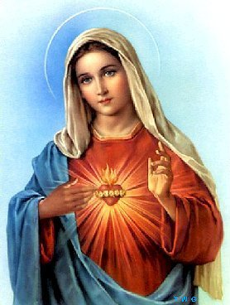
Theme: With Mary – A Journey of Faith, Hope and Love. As we enter the beautiful month of May, dedicated to Mary, the Mother of the Church, we move into a new and prayerful stage of our 200th Anniversary celebrations at St Joseph’s. Having honoured our history and celebrated new life in Baptism, we now turn to Our Lady, who gently leads us ever closer to her Son. SUNDAY 17TH MAY – CROWNING OF OUR LADY and ROSARY PROCESSION
We warmly invite all parishioners, families, and especially our children, to take part in a special Crowning of Our Lady and Rosary Procession on Sunday 17th May.
Together, we will: Honour Mary as our Mother and Queen Pray the Rosary for our parish, our families, and peace in the world. Entrust the next chapter of our parish journey to her loving care. Children are especially invited to take part in the crowning, a beautiful and memorable moment in our celebration.
This will be a joyful and prayerful gathering, uniting generations in faith, as we continue to give thanks for 200 years of St Joseph’s Church and look forward with hope to the future.
Further details to follow.
Let us walk with Mary, trusting in her intercession, as we continue this amazing journey together. “My soul glorifies the Lord, and my spirit rejoices in God my Saviour.

CEMENTRY SUNDAYS: – Invitation You are warmly invited to our Cemetery Sunday Masses, as we remember and pray for our loved ones.
D&C DIOCESE & HANNAHSTOWN & FAMILY OF PARISHES NEWS NWESNNEWS
Sunday 31st May – St Joseph’s Sunday, 7th June – St Peter’s,
Sunday 14th June – Tullyrusk All are most welcome.
“I am the resurrection and the life, says the Lord; whoever believes in me will live, even though they die.”


LIGHTS, CAMERA, ACTION! – BBC Drama Time

Our Parish Church will be used as a filming location for the acclaimed BBC drama Time (starring actors such as Sean Bean and Stephen Graham). Members of the congregation are invited to apply to be extras in the filming. If interested, please register with the casting company at: https://www.theextrasdept.com/ A wonderful and unique moment in our bicentenary year — our parish moving from 200 years of history to prime-time television!
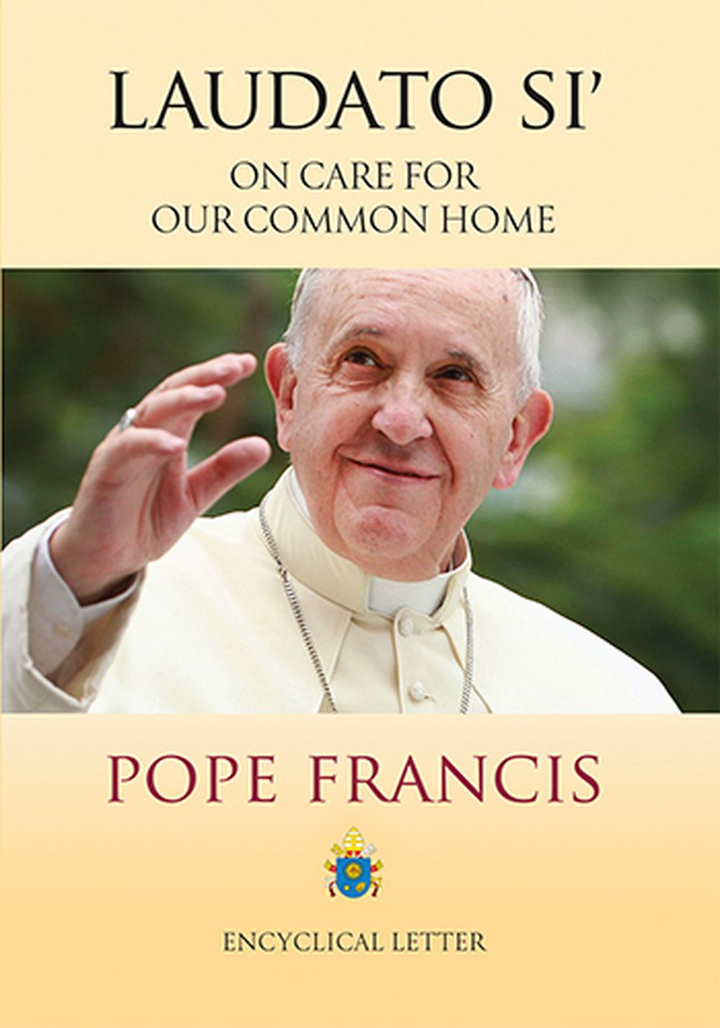
PARISH FOLK GROUP- We are hoping to further enhance congregational singing at our 11.30am Mass and would love to hear your suggestions. If there are any hymns you particularly enjoy or would like to hear at Mass, please let us know. If you are having a Mass celebrated for a loved one and there is a favourite hymn or piece of music that would mean something special to your family, we would be very happy to try to include it. Please speak to a member of the Folk Group after Mass or message Tina on 07746 620553. All suggestions are very welcome. If we do not already know the hymn, we will do our best to learn it for you.
LAUDATO SI CONFERENCE (QUB) When: April 22, 2026 @ 9:30 am – 1:00 pm
Where: Queens University Belfast
A great opportunity to hear from Dr Lorna Gold, Executive Director Laudato Si’, and also to meet with Lorna in person. Join others who share a common interest in living more sustainably; discuss actions that are being implemented and their impact; explore bold alternatives to our economic system. Your presence and contribution is very welcome.

Down and Connor Diocesan Pilgrimage to Lourdes 2026
Dates: 8th – 15th July 2026
The Diocese of Down and Connor invites you to join this year’s pilgrimage to Lourdes, a sacred journey of prayer, reflection, and renewal. Lourdes has long been a place of healing and hope, where pilgrims from around the world gather in faith, seeking the intercession of Our Lady and the peace that comes from encountering God’s presence.
This pilgrimage offers a unique opportunity to step away from the busyness of daily life and enter into a deeper relationship with Christ. Through participation in the Sacraments, processions, and times of quiet prayer at the Grotto, pilgrims are invited to place their intentions before the Lord and to walk in solidarity with the sick and those in need. Whether you are travelling for the first time or returning once more, all are welcome—especially those seeking spiritual renewal, companionship in faith, or the grace of healing. Let us journey together as a diocesan family, united in prayer and devotion. For further information or to register, please contact the Diocesan Pilgrimage Office. Come to me, all you who labour and are burdened, and I will give you rest." (Matthew 11:28)

