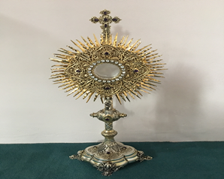
EUCHARISTIC ADORATIONSt Peter’s Church - Every Friday from 2 pm – 8.30 pm. Every evening Adoration & Prayer in St Peter’s Church 6.30 pm – 7.30 pm
THE PARISH OF HANNAHSTOWN
https://churchmedia.tv/st-josephs-church https://churchmedia.tv/st-peters-church-2

RECENTLY DECEASED Mary Curran RIP
& Kathleen Rafferty RIP
ANNIVERSARIES – Jack Ellis, Annie & Bernard Rooney, Wilhelmena Trainor, Sheila Owens
& Carol Vickery RIP


WEEKLY COLLECTIONS
14/04/25 Weekly Collection £1064.89
07/04/25 Building Collection £ 462.24
Thank you to everyone for their generosity to the Parish.


BAPTISMS
We recently welcomed Baby Caitlin Grace Bellew into our parish family.
To book a Baptism, please come to the parish office with the baby’s long birth certificate, thank you.

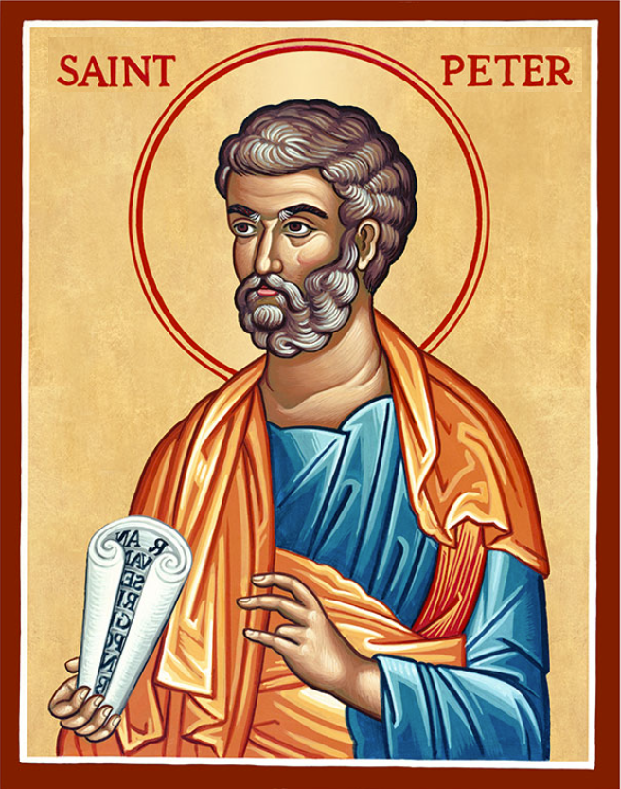
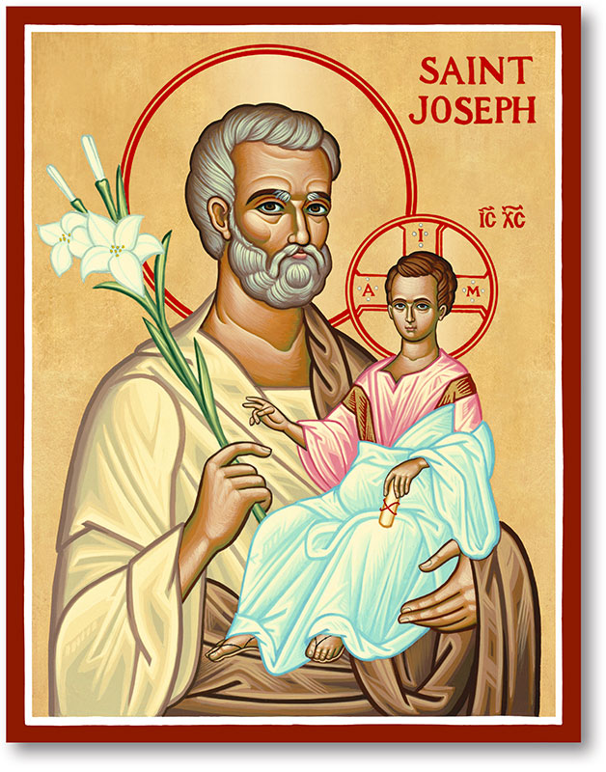
The Parish of Hannahstown
Saint Joseph’s and Saint Peter’s

20th April 2025

Easter Day of the Lord’s Ressurrection


THE DAWN OF EASTER BREAKS FORTH
Every time we ask forgiveness of one another for our sins against other Christians, and every time we find the courage to grant and receive such forgiveness, we experience the Resurrection!
Every time we put behind us our long-standing prejudices and find the courage to build new fraternal relationships, we confess that Christ is truly risen!
Every time we reflect on the future of the Church in the light of her vocation to unity, the dawn of Easter breaks forth!
Fr Patrick Devlin hopes that during this Easter season you will experience the mercy, compassion and inner peace that the Risen Lord promises. Amd would like to wish all parishioners, their families and friends a very Happy Easter.
Parish Office Closed – The parish office will be closed on Good Friday 18th April and will Re-Open on Monday 28th April. For all urgent enquires please leave a message on the office phone and we will endeavor to get back to you as all messages will be checked daily. For any pastoral urgent enquiries please ring Fr. Patricks mobile (07910 833699) number or Emergency vicariate number (07549209775). Many Thanks
HANNAHSTOWN PARISH / FAMILY OF PARISHES / PATHWAYS
Week day Mass times from Monday 21st April as normal
Monday 9.15 am in St Joseph’s
Tuesday Fr. Patrick day off
Wednesday 9.15 am in St Joseph’s Church
Thursday 9.15 am in St Peter’s Church
Friday 9.15 am in St Joseph’s Church
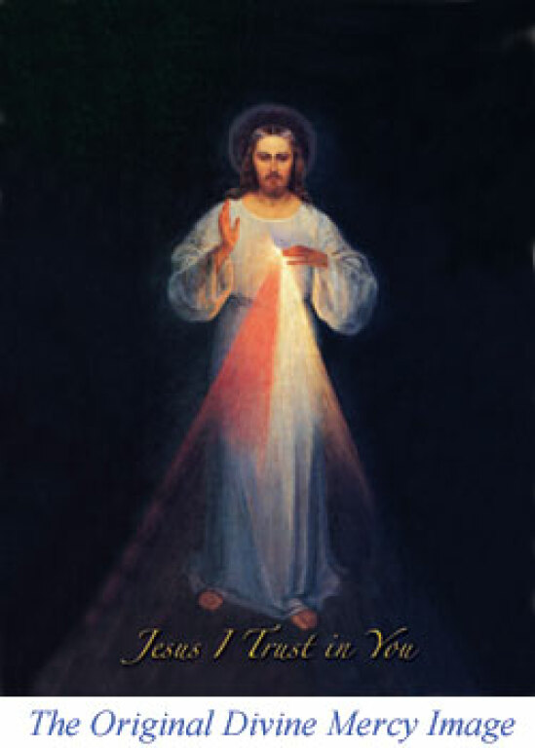
DIVINE MERCY SUNDAY - Would you like your soul to be as pure as on the day you were baptised?
If the answer is yes, read on. St Pope John Paul II canonized a Polish mystic, Sister Faustina (1905 – 1938) on the Sunday after Easter in 2000 and declared that from then on, the second Sunday of Easter would be known as Divine Mercy Sunday.
In a revelation to Sister Faustina (recorded in her Diary 1109) Jesus told her, ‘I want to grant a complete pardon to the souls that will go to confessions and receive Holy Communion on the Feast of My Mercy’ (Divine Mercy Sunday).
The conditions for receiving this great grace, including going to confessions, can be fulfilled by attending any of the following Churches on Divine Mercy Sunday, 27 April this year. St Peter’s Cathedral at 2pm,
or St Paul’s, Falls Rd at 2pm.

Our Parish School Ballymacward Primary School,
THE PARISH OF HANNAHSTOWN SCHOOLS
22 Rock Road, Stoneyford, Lisburn, Co Antrim, BT28 3SUTel: (028) 92648130, Principal: Mr Hugh Kennedy
Email: info@ballmacwardps.lisburn.ni.sch.uk
Pre-School Playgroup - Supervisor: Ms Sarah Scott. Tel: (028) 9264 8515

HANNAHSTOWN PARISH / FAMILY OF PARISHES / PATHWAYS
‘Sing for Joy!' – A Reflective Day of Music and Ministry - ‘Sing for Joy!' - A Reflective Day of Music and Ministry. Saturday 26th April 2025 at Lough Derg, Pettigo, Co. Donegal. In the prayerful setting of Lough Derg, this day will provide space for the power of music to nourish our spirit and allow us to give praise to God through the beauty of sound, song and silence. There will be various inputs as well as time to pray, connect with others and explore this Sacred place. The day will conclude with the Celebration of the Eucharist at 3:30pm (open to the public).
This day is open to young people aged 18-35 and is free to attend (supported by the Knights of St Columbanus). Boat departs at 9:30am.
Registration is essential via https://bit.ly/SingforJoy . For further information please contact info@knightsofstcolumbanusomagh.co.uk / +447759496677
Seeking Educational & Sensory Toy Donations!

I am collecting new or gently used educational and sensory toys Saint Joseph’Sc Centre for the Deaf, to support children’s learning and development. These toys will benefit children who thrive with hands-on, engaging play that builds important skills.

Items we’re looking for include:
• Puzzles, building blocks, and STEM toys
• Fidget tools, textured toys, and sensory bins
• Cause-and-effect or interactive learning toys
Indoor outdoor play equipment

Please drop off donations by Friday 26th April noon or contact Fr.Patrick for collection on 07910833699 Thank you for helping us create a supportive and fun learning environment for all children!

