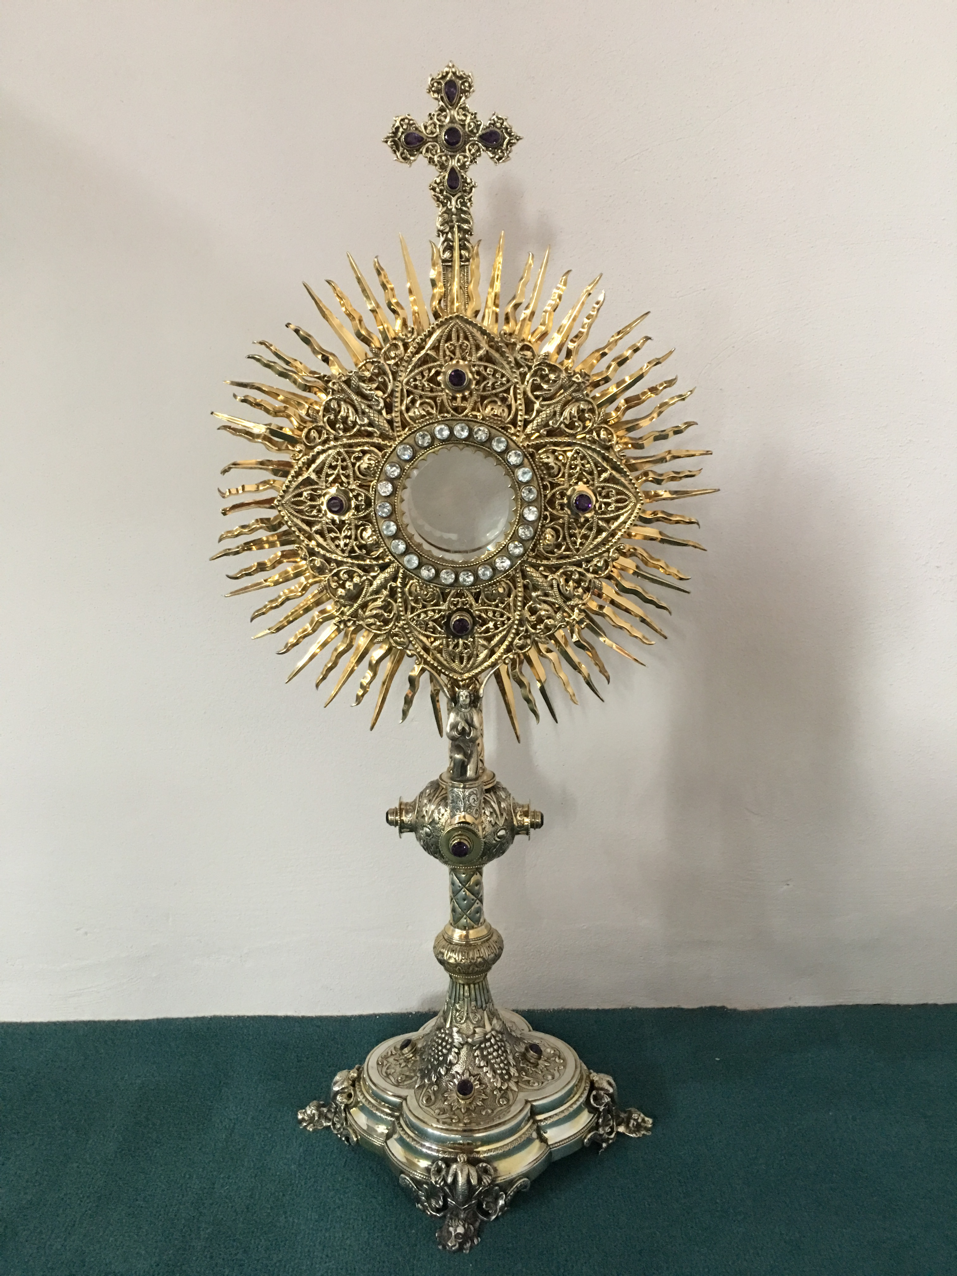
EUCHARISTIC ADORATION
The Parish of Hannahstown News
St Peter’s Church - Every Friday from 2 pm – 8.30 pm. Every evening Adoration & Prayer in St Peter’s Church 6.30 pm – 7.30 pm.
St Joseph’s Church Wednesdays during Lent from 9.45 am – 1.45 pm. You can join us in the Church or via the webcam. https://churchmedia.tv/st-josephs-church https://churchmedia.tv/st-peters-church-2

ANNIVERSARIES – Mary & Paddy Cunningham, Hughie Jordan, Neil McCague, Joan, Skelly, Paul Skelly & Billy Skelly RIP.

WEEKLY COLLECTIONS
03/03/2024 Weekly Collection £1009.72
03/03/2024 Monthly Collection £695.16
Thank you to everyone for their generosity to the Parish.
BAPTISMS Last weekend we welcomed Ruairi Kevin Scott, Padraig Piaras Lynch & Erin Theresa McGarrity into our parish community.
PRE-BAPTISM COURSES – Attendance at a Pre-Baptism course is required for all parents presenting a first baby for Baptism.
To book a Baptism, please visit the parish office with the new baby’s long birth certificate.

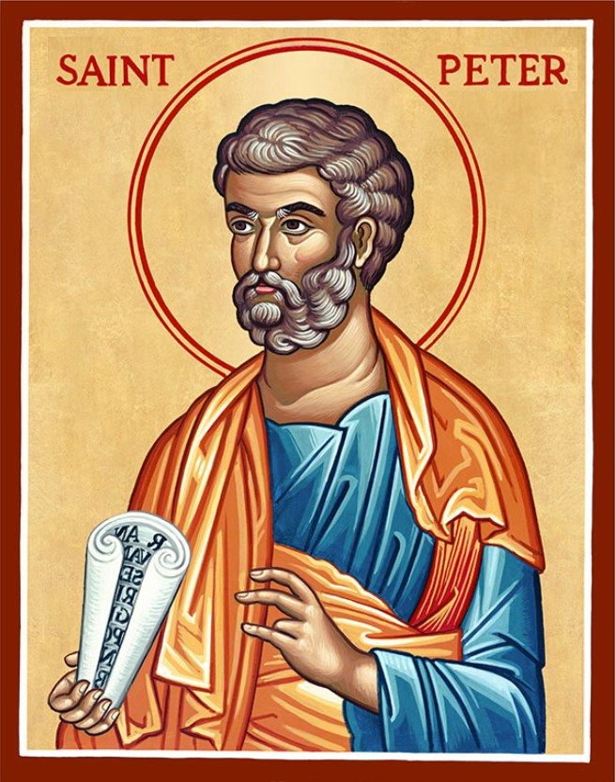
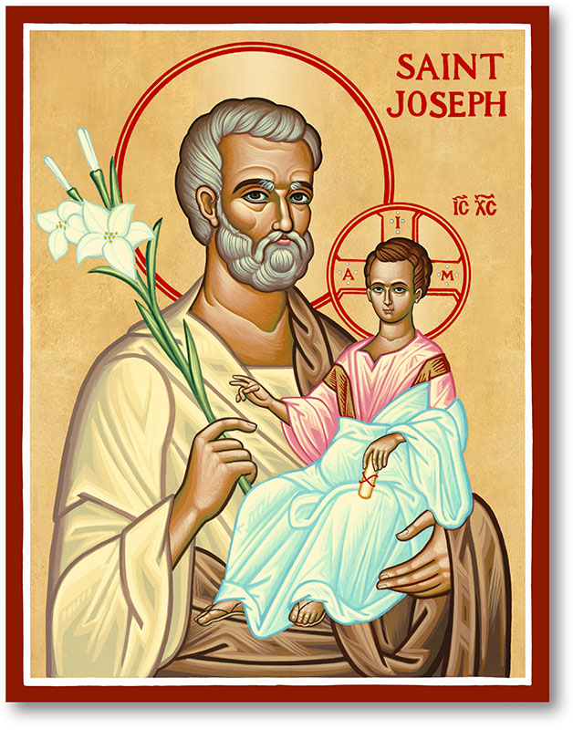
The Parish of Hannahstown
Saint Joseph’s and Saint Peter’s

10th March 2024
Second Sunday of Lent

Vicariate / Family of Parishes Emergency Sick Calls: 07549209775
Readings: Sunday Cycle B Weekdays Psalter Week
Monday/Tuesday Parish Pilgrimage to Knock
Monday 09:15 am (Prayer for Vocations) Saint Joseph’s
Wednesday 09.15 am (Parish Novena to Our Lady) Saint Joseph’s
Thursday 09:15 am (Parish Novena to Our Lady) Saint Peter’s
Friday 09:15 am (Sacred Heart Prayer) Saint Joseph’s
Saturday 6:00 pm (St Michael the Archangel Prayer) Saint Joseph’s Sunday 10:00 am (Prayer for Pope’s Intentions) Saint Peter’s
Sunday 11:30 am (St Joseph Prayer) BSL Signed Mass Saint Joseph’s
Very Reverend Patrick Devlin Parish Priest,
Chaplain to the Deaf Community, Down and Connor Diocese
Chaplain to Antrim Area Hospital Thursday & Friday (Emergency calls)
(Fr. Patrick’s mobile…. For Spiritual and pastoral needs only, thank you) Tel: 07910 833699
Parish Secretary: Mrs Grainne McArevey Tel: 028 90614567
Parish Email: hannahstown@downandconnor.org
Parish Website: https://www.parishofhannahstown.com
FOURTH SUNDAY OF LENT
(Laetare Sunday)

Laetare Sunday reminds us of the Event we look forward to at the end of the penitential season. The central theme of today’s readings is that our salvation is the free gift of a merciful God given to us through Jesus, His, Son. The readings stress God’s mercy and compassion and remind us of the great love, kindness and grace extended to us in Christ. We need to love the cross, the symbol of God’s forgiving and merciful love? The crucifix – the symbol of the ‘lifted up’ Jesus – holds a central place in our Churches because it is a forceful reminder not only of God’s love and mercy, but also of the price of our salvation. Hence, no Christian home should be without this symbol of God’s love. The crucifix invites us to respond with more than compassion; it inspires us to remove the suffering of other people’s misery. When we allow the Light of God’s forgiveness to shine in our lives, it brightens up every corner, forgives every sin, restores our relationship with God and renews our lives. Whoever follows Jesus will not walk in darkness.
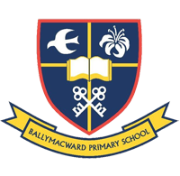
Our Parish School Ballymacward Primary School,
THE PARISH OF HANNAHSTOWN SCHOOLS
22 Rock Road, Stoneyford, Lisburn, Co Antrim, BT28 3SUTel: (028) 92648130, Principal: Mr Hugh Kennedy
Email: info@ballmacwardps.lisburn.ni.sch.uk

Pre-School Playgroup - Supervisor: Ms Sarah Scott. Tel: (028) 9264 8515
HANNAHSTOWN COMMUNITY HALL
Please contact Anthony Adams for any enquiries on 90 309795
Mon – Fri 10 am – 1 pm.
Monday – Coffee Morning after 9.15 am Mass, everyone welcome.

LIVING CHURCH / WEST BELFAST PASTORAL COMMUNITY NEWS
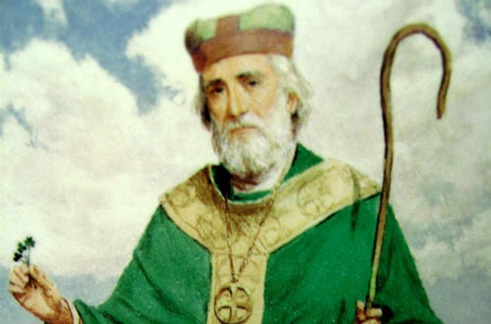
SAINT PATRICK’ DAWN PRAYER GATHERING – Continuing the legacy of Saint Patrick who tells us in his Confessions that he rose as many as one hundred times before dawn to pray, a group of Christians will gather at 5.45 am at his grave on Saint Patrick’s morning 17th March. We will pray The Our Father/The Lord’s Prayer one hundred times for peace and unity in Christ among our peoples. Everyone welcome.

A ST PATRICK'S WAY pilgrimage experience - in Downpatrick on March 16, led by pilgrim guides Martina Purdy and Elaine Kelly. Visit The Saint Patrick Centre, see the IMAX film, & receive a passport to walk with guides to Inch Abbey and Saul Church & St Patrick's grave. Lunch and bus transfers Inc. £35 pp. 9 am-3 pm More info contact the Centre 02844 619000 (The walk is approx. 6 miles).
WALKING WITH JESUS – Week 4 Lenten Reflection Booklets designed by Living Church Down & Connor are available in the Church porch. They have beautiful reflections and prayers, we encourage you to all take one.
LIVING CHURCH / WEST BELFAST PASTORAL COMMUNITY
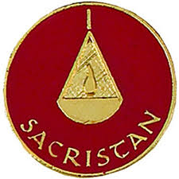
CARETAKER / SACRISTAN- Required for Hannahstown Parish. The terms are based on a permanent appointment requiring 24-hours attendance each week Monday – Sunday, work pattern to be agreed. Availability to work flexible hours is required from time to time. Rate of Pay - £10.42 gross per hour. Full details can be found on the Diocesan website at: http://www.downandconnor.org click on Job Vacancies. Application packs can also be obtained from the Hannahstown Parish Office. Closing date Monday 11th March 2024 @ noon.

Spiritual and Pastoral Commitments: March 2024 - June 2024 Update

10th of March 2024, a Celebration of the Eucharist Saint Peter’s 10:00 am Mass (Invitation to Previous Children’s Communion Since 2022).
11th & 12th of March 2024, Parish Pilgrimage to Knock.
17th of March 2024, Saint Patrick’s Day Saint Peters 10:00 am and Saint Joseph’s 11:30 am (Irish Dancers).
5th of May 2024, Parish School First Holy Communion, Saint Peter’s 10:00 am.
24th of March 2024, 5:00 pm-6:00 pm Saint Joseph’s Penitential Service
24th of March 2024, Palm Sunday Carrying the Cross, Saint Peter’s at 9:45 am and Saint Joseph’s at 11:00 am.
28th of March 2024, The Last Supper, Washing of the Feet, Saint Joseph’s 7:00 pm.
29th of March 2024, Good Friday, Stations of the Cross, Saint Peter’s 7:00 pm
Easter
30th March 2024, Easter Vigil Mass, Saint Joseph’s 6.00 pm Mass
31st March 2024, Easter Sunday, Saint Peter’s 10:00 am Mass
31st of March 2024, Easter Sunday, Saint Joseph’s 11:30 am Mass with Baptism.
5th of May 2024, Parish School First Holy Communion, Saint Peter’s 10:00 am.

