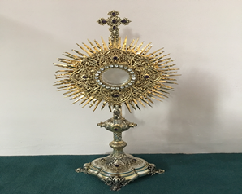**EUCHARISTIC ADORATION in St Peter’s Church - Every Friday from 2 pm – 8.30 pm.**

THE PARISH OF HANNAHSTOWN

**Every evening with in St Peter’s Church Adoration & Prayer from 6.30 pm – 7.30 pm**

**https://churchmedia.tv/st-josephs-church https://churchmedia.tv/st-peters-church-2**



**ANNIVERSARIES** – Peter Campbell, Mary Hickland Thomas McKeever, Sean Mullan & PJ O’Neill RIP

**WEEKLY COLLECTIONS**

**11/05/25 Weekly Collection £1,127.36**

**11/05/25 Education Student Priests £ 386.27**

***Thank you to everyone for their generosity to the* Parish.**



**BAPTISMS**

To arrange Baptisms please present the long birth certificate to the parish office. Baptisms will be arranged upon request.

**CEMETERY SUNDAY**

St Peter’s The Rock on 8th June @ 3 pm

Tullyrusk on 15th June @ 3 pm

**If you are available to serve as a minister for the Holy Eucharist please let Fr. Patrick know. Thank you.**

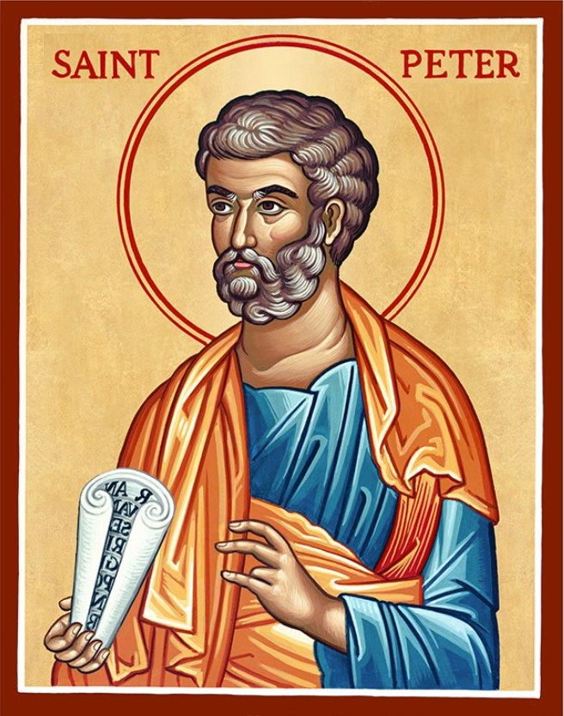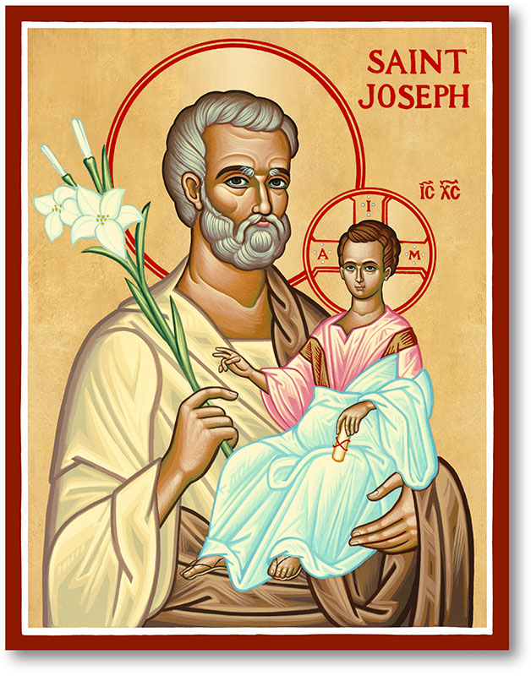

The Parish of Hannahstown

Saint Joseph’s and Saint Peter’s

**25th May 2025**

**Sixth Sunday of Easter**

**Family of Parishes Emergency Sick Calls: 07549209775**

Monday 09.15 am (Prayer for Vocations) Saint Joseph’s

Tuesday Fr. Patrick’s day off.

Wednesday 9.15 am (Parish novena to Our Lady) St Joseph’s

Thursday 9.15 am (Parish novena to Our Lady) St Peter’s

Friday 9.15 am (Sacred Heart Prayer) Saint Joseph’s

Saturday 6:00 pm (St Michael the Archangel Prayer) Saint Joseph’s

Sunday 10:00 am (Prayer for Pope’s intentions) Saint Peter’s

Sunday 11:30 am (Saint Joseph Prayer) ( BSL Signed ) Saint Joseph’s

**Very Reverend Patrick Devlin, Parish Priest,**

**Chaplain to the Deaf Community, Down and Connor Diocese**

**Chaplain to Antrim Area Hospital, Thursday & Friday (Emergency calls)**

Fr. Patrick, for Spiritual and Pastoral needs **only**, thank you Tel: 07910 833699

**Parish Secretary: Mrs Grainne McArevey** [**Tel: 028 90614567**](Tel:02890614567)

**Parish Email:** [**hannahstown@downandconnor.org**](mailto:hannahstown@downandconnor.org) **Parish Website: https://www.parishofhannahstown.com**



**PRAYER BEFORE EXAMINATIONS**

**Loving God,** be with me now as I prepare for my exams. Thank you for the many talents, gifts and the opportunity of education you have given me. Calm my nerves & anxiety, help me to remember all that I have studied, to express it clearly and to answer the questions to the very best of my ability. Holy Spirit, be with me in my exams – and always. Amen

**‘Do not be anxious about anything, but in every situation, by prayer and petition, with thanksgiving, present your requests to God.’ (Philippian 4:6)**

**Our Parish School Ballymacward Primary School,**

HANNAHSTOWN PARISH SCHOOL / COMMUNITY PLAYGROUP

**22 Rock Road, Stoneyford, Lisburn, Co Antrim, BT28 3SUTel: (028) 92648130, Principal: Mr Hugh Kennedy**

**Email:** [**info@ballmacwardps.lisburn.ni.sch.uk**](mailto:info@ballmacwardps.lisburn.ni.sch.uk)

**Ballymacward Community Pre-School Playgroup - Supervisor: Ms Sarah Scott. Tel: (028) 9264 8515**

HANNAHSTOWN COMMUNITY HALL

Please contact Anthony Adams for any enquiries on 90 309795.

Mon – Fri 10 am – 1 pm.

Monday – Coffee Morning after 9.15 am Mass.

Wednesday Morning Seniors Group after 9.15 am Mass

**BRIC-A-BRAC ITEMS REQUIRED, GOOD QUALITY CLOTHING-HOUSEHOLD ITEMS-GAMES AND TOYS. CONTACT 90- 309795**

_______________________________________________________________________________________

**DAY RETREAT SUN 1st JUNE** - Benburb Priory Fr John Keane will have a day Retreat in Benburb. Blessing of First Class Relics of St Peregrine and Blessed Carlo Acutis Departure Kennedy Way 9.30am

Return Benburb 4.30pm, £18 return. Tel: 07810111097

**DROMANTINE FAMILY FUN DAY**  - SUNDAY 8TH JUNE 2025 1.00 pm – 5.30 pm. ATTRACTIONS Grand Draw, Country & Western Music, Vintage Tractors, Gun Dog Display, Bouncy Castles, Obstacle Courses, Amusements, Pony & Trap Rides, Stalls, Food, Refreshments and much more! Admission-Donation £5 per car. Everyone Welcome. Society of African Missions 96 Glen Road, Newry, BT34 1RH

Family of Parishes

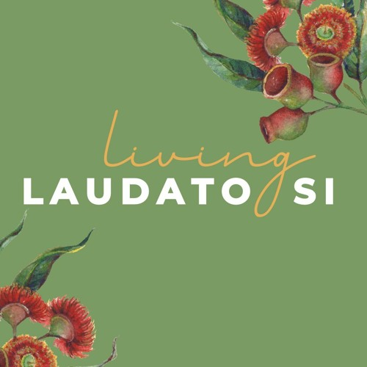**LIVING LAUDATO SI CONFERENCE** - Raising Hope - Living Laudato Si’' conference, May 25th in Clonard Monastery.

There is also a letter from Bishop Alan regarding Laudato Si week displayed in the Church porch. A QR code is also displayed. If you scan the code it will bring your directly bring to the D&C Website where you can see what other events are happening to mark Laudato Si Week -

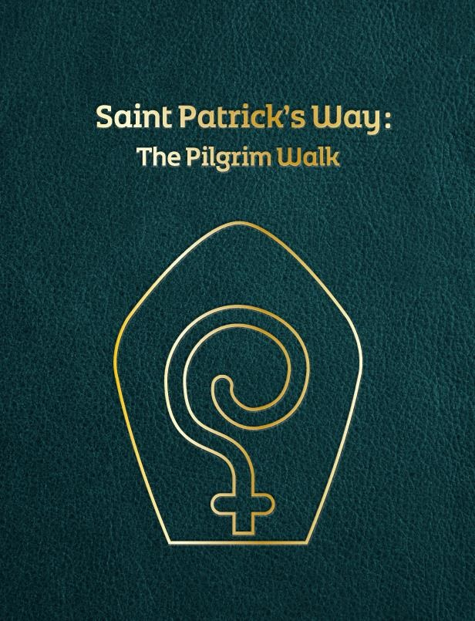

**St Patrick’s Way Pilgrimage** - In this Jubilee Year of Hope, come on an authentic ST PATRICK'S WAY pilgrimage experience in Downpatrick on 7 June, or 5 July or 9 August,  led by pilgrim guides Martina Purdy and Elaine Kelly. For more info contact the Centre 028 4461 9000  or book online [www.saintpatrickcentre.com/experiences/](https://url.uk.m.mimecastprotect.com/s/d-73CpzmQtlLm6sDhGfG5iwJ?domain=saintpatrickcentre.com) **Summer**

**Singing Course -** 7-11 July 2025. 5-day singing course for young people who want to improve their singing voice and musical skills. For young people aged 8-18. Venue: St Paul's Parish Centre, Belfast, End of week showcase: St Peter's Cathedral. Optional extra sessions for singers studying GSCE and A Level Music performance. £75 for 5-day course. Book by 31st May for discount -£50 for 5-day course Scholarships available on request. For more information or to apply, please contact [cathedralmusic@downandconnor.org](mailto:cathedralmusic@downandconnor.org)