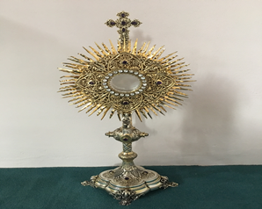
EUCHARISTIC ADORATION in St Peter’s Church - Every Friday from 2 pm – 8.30 pm.
THE PARISH OF HANNAHSTOWN
Every evening with in St Peter’s Church Adoration & Prayer from 6.30 pm – 7.30 pm
https://churchmedia.tv/st-josephs-church https://churchmedia.tv/st-peters-church-2

ANNIVERSARIES – Peter Campbell, Mary Hickland Thomas McKeever, Sean Mullan & PJ O’Neill RIP


WEEKLY COLLECTIONS
11/05/25 Weekly Collection £1,127.36
11/05/25 Education Student Priests £ 386.27

Thank you to everyone for their generosity to the Parish.

BAPTISMS
To arrange Baptisms please present the long birth certificate to the parish office. Baptisms will be arranged upon request.


CEMETERY SUNDAY
St Peter’s The Rock on 8th June @ 3 pm
Tullyrusk on 15th June @ 3 pm
If you are available to serve as a minister for the Holy Eucharist please let Fr. Patrick know. Thank you.

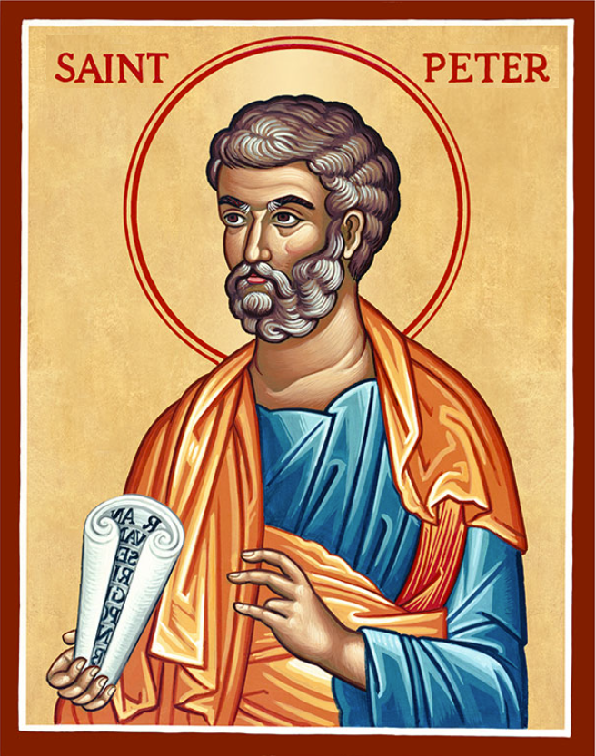
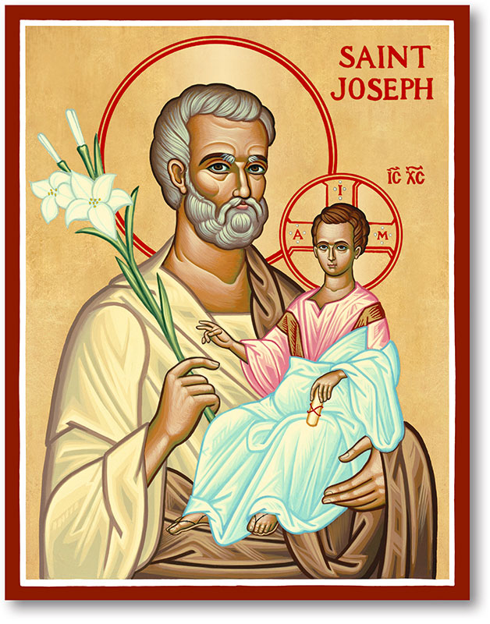
The Parish of Hannahstown
Saint Joseph’s and Saint Peter’s

25th May 2025

Sixth Sunday of Easter
Family of Parishes Emergency Sick Calls: 07549209775
Monday 09.15 am (Prayer for Vocations) Saint Joseph’s
Tuesday Fr. Patrick’s day off.
Wednesday 9.15 am (Parish novena to Our Lady) St Joseph’s
Thursday 9.15 am (Parish novena to Our Lady) St Peter’s
Friday 9.15 am (Sacred Heart Prayer) Saint Joseph’s
Saturday 6:00 pm (St Michael the Archangel Prayer) Saint Joseph’s
Sunday 10:00 am (Prayer for Pope’s intentions) Saint Peter’s
Sunday 11:30 am (Saint Joseph Prayer) ( BSL Signed ) Saint Joseph’s

Very Reverend Patrick Devlin, Parish Priest,
Chaplain to the Deaf Community, Down and Connor Diocese
Chaplain to Antrim Area Hospital, Thursday & Friday (Emergency calls)
Fr. Patrick, for Spiritual and Pastoral needs only, thank you Tel: 07910 833699
Parish Secretary: Mrs Grainne McArevey Tel: 028 90614567
Parish Email: hannahstown@downandconnor.org Parish Website: https://www.parishofhannahstown.com

PRAYER BEFORE EXAMINATIONS
Loving God, be with me now as I prepare for my exams. Thank you for the many talents, gifts and the opportunity of education you have given me. Calm my nerves & anxiety, help me to remember all that I have studied, to express it clearly and to answer the questions to the very best of my ability. Holy Spirit, be with me in my exams – and always. Amen

‘Do not be anxious about anything, but in every situation, by prayer and petition, with thanksgiving, present your requests to God.’ (Philippian 4:6)

Our Parish School Ballymacward Primary School,
HANNAHSTOWN PARISH SCHOOL / COMMUNITY PLAYGROUP
22 Rock Road, Stoneyford, Lisburn, Co Antrim, BT28 3SUTel: (028) 92648130, Principal: Mr Hugh Kennedy
Email: info@ballmacwardps.lisburn.ni.sch.uk
Ballymacward Community Pre-School Playgroup - Supervisor: Ms Sarah Scott. Tel: (028) 9264 8515
HANNAHSTOWN COMMUNITY HALL
Please contact Anthony Adams for any enquiries on 90 309795.
Mon – Fri 10 am – 1 pm.
Monday – Coffee Morning after 9.15 am Mass.


Wednesday Morning Seniors Group after 9.15 am Mass

BRIC-A-BRAC ITEMS REQUIRED, GOOD QUALITY CLOTHING-HOUSEHOLD ITEMS-GAMES AND TOYS. CONTACT 90- 309795
_______________________________________________________________________________________
DAY RETREAT SUN 1st JUNE - Benburb Priory Fr John Keane will have a day Retreat in Benburb. Blessing of First Class Relics of St Peregrine and Blessed Carlo Acutis Departure Kennedy Way 9.30am
Return Benburb 4.30pm, £18 return. Tel: 07810111097

DROMANTINE FAMILY FUN DAY - SUNDAY 8TH JUNE 2025 1.00 pm – 5.30 pm. ATTRACTIONS Grand Draw, Country & Western Music, Vintage Tractors, Gun Dog Display, Bouncy Castles, Obstacle Courses, Amusements, Pony & Trap Rides, Stalls, Food, Refreshments and much more! Admission-Donation £5 per car. Everyone Welcome. Society of African Missions 96 Glen Road, Newry, BT34 1RH
Family of Parishes
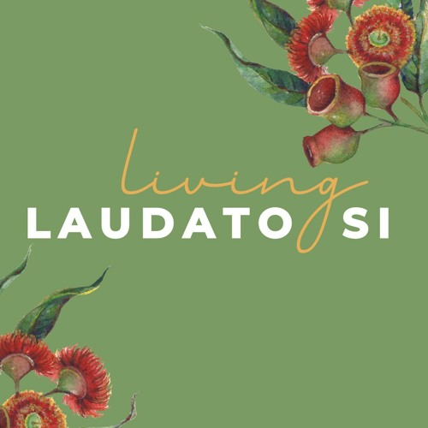
LIVING LAUDATO SI CONFERENCE - Raising Hope - Living Laudato Si’' conference, May 25th in Clonard Monastery.
There is also a letter from Bishop Alan regarding Laudato Si week displayed in the Church porch. A QR code is also displayed. If you scan the code it will bring your directly bring to the D&C Website where you can see what other events are happening to mark Laudato Si Week -
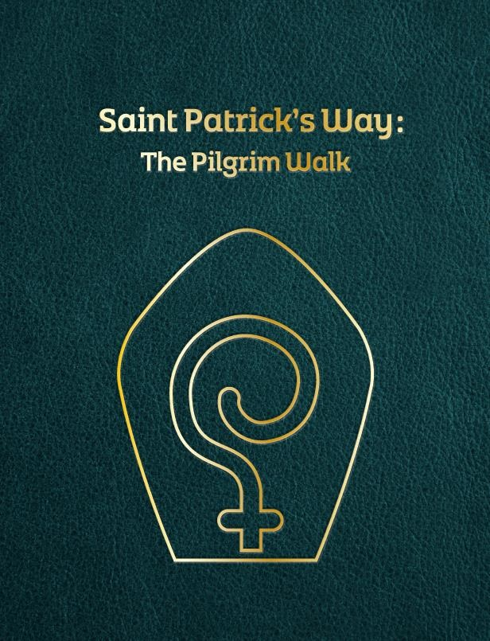
St Patrick’s Way Pilgrimage - In this Jubilee Year of Hope, come on an authentic ST PATRICK'S WAY pilgrimage experience in Downpatrick on 7 June, or 5 July or 9 August, led by pilgrim guides Martina Purdy and Elaine Kelly. For more info contact the Centre 028 4461 9000 or book online www.saintpatrickcentre.com/experiences/ Summer

Singing Course - 7-11 July 2025. 5-day singing course for young people who want to improve their singing voice and musical skills. For young people aged 8-18. Venue: St Paul's Parish Centre, Belfast, End of week showcase: St Peter's Cathedral. Optional extra sessions for singers studying GSCE and A Level Music performance. £75 for 5-day course. Book by 31st May for discount -£50 for 5-day course Scholarships available on request. For more information or to apply, please contact cathedralmusic@downandconnor.org

